**Java**

**Java:** Object oriented programming language that is class-based and High level language.

**Jshell:** REPL (Read Evaluate Print Loop) 🡪 Helps in faster evaluation of code written and was introduced in *Java 9* onwards.

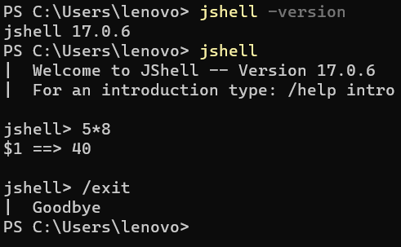

* 5*5 🡺 Expression (5 🡪 Literal/Operands on which operations performed) (* 🡪 Predefined functions performs some operation)
* **Precedence** 🡪 Higher priority 🡺 **()** ***\* / % > + - ++ --***
* *method_path(parameter)* 🡪 System.out.println(3*4) 🡪 *Statement*

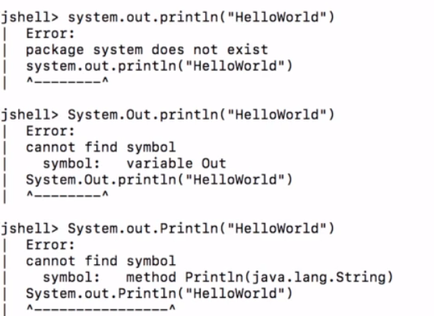

* Escape “ quotes with escape character \.*Escape characters : \n (new line) \t (tab) \ (Escape char)*



* ***Math.random()*** 🡪 Generates random value b/w 0 and 1. No parameter.
* ***Math.min()/Math.max()*** 🡪 Returns minimum/maximum of 2 variables. Require parameters.

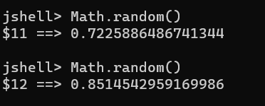

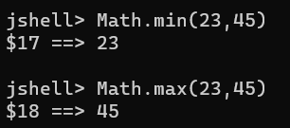

* ***System.out.printf()*** 🡪 It allows formatting to be printed which println() doesn’t support and also prints stream. For example : ***%d(Number), %s(String) and %f(Float)***.

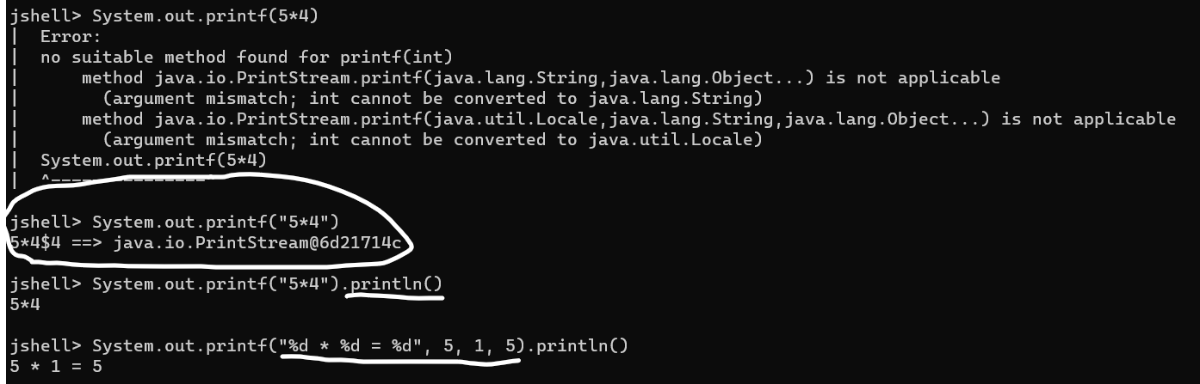

* ***Challenge 1***:- *Multiplication table of 5 using Jshell*.

***Using System.out.println() Using System.out.printf()***

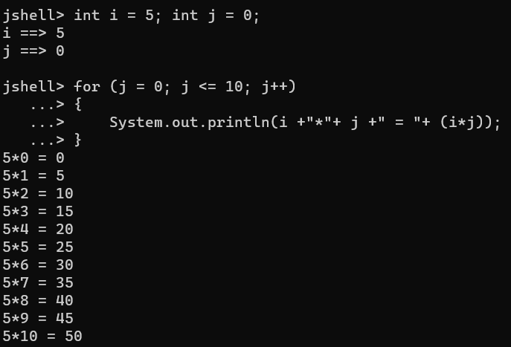 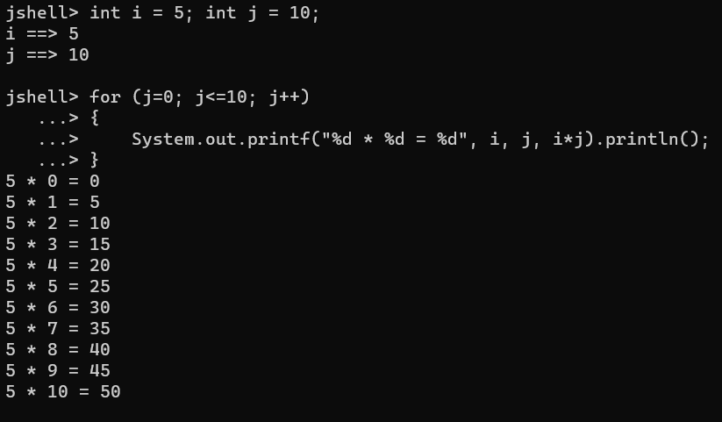

**Variables:** Variables are containers for storing data values. Variables have name, value and memory location. For example: int a = 100; int b = 110; int c = a + b;

***Primitive Data type vs Primitive Variable***: Basic data types build in Java and Variable that stores single value of Primitive data type.

|  |  |  |
| --- | --- | --- |
| **Memory Location** | **Value** | **Name** |
| 5002 | 100 | a |
| 5006 | 110 | b |
| 5012 | 210 | c |

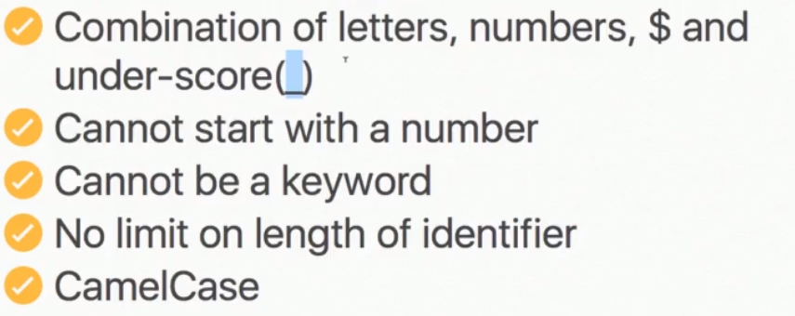 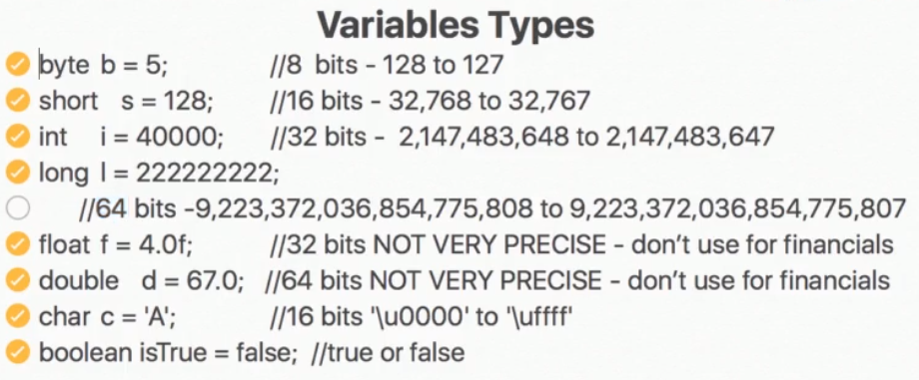

Note: Float variable is by default double so we use ‘f’. Ex : float a = 4.5f; double b = 4.5;

**String Concatenation:-**

* If we add (+) one *String* with other *Short, Byte, Integer, Long, Float, Double, Boolean* result will be *String*.

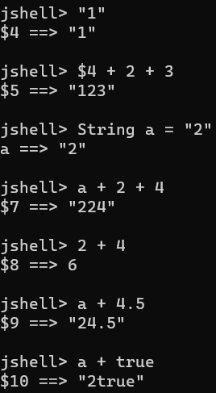

**Operators:-**

**= 🡪 Assignment Operator**

**==, <, >, <=, >= 🡪 Comparison Operator**

**&&,||, ^, ! 🡪 Logical Operator (Result is always true/false or boolean value)**

**-=, +=, /=, *=, %= 🡪 Compound Operators**

**++, -- 🡪 Increment/Decrement Operator**

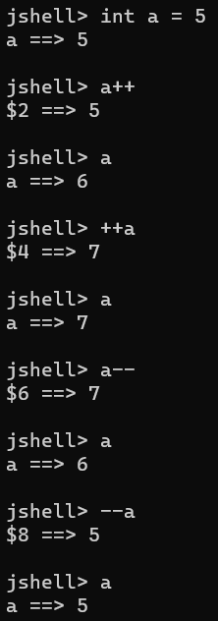 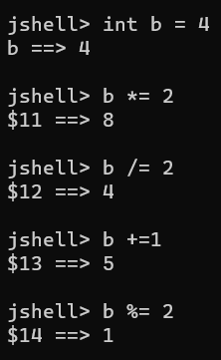

**Conditions:-**

* **If Condition:** Executes ‘*If*’ inside statement only if condition is *‘true’*, otherwise no print.

*If(condition)*

*{*

*Statement;*

*}*

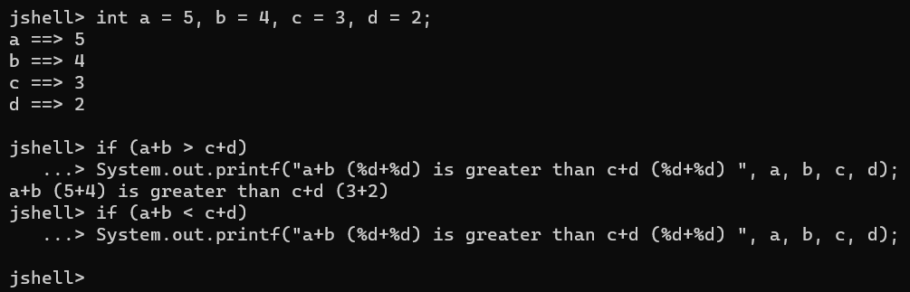

* ***Challenge 2*:** *Sum of 3 angles if true print Triangle formed and check if number is even using Jshell.*

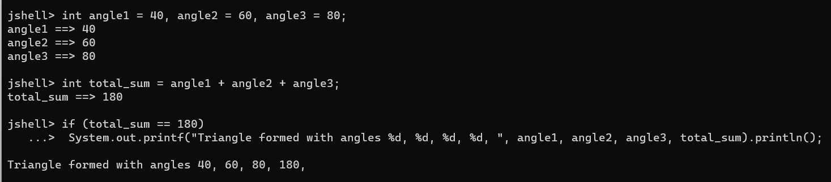

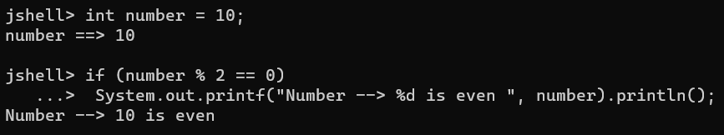

* **for loop:-** *for(initialization; condition; update)*

*{*

*Statement;*

*}*



* **Challenge 3:** Print number in reverse from 10 to 0 and print first 10 number square if it’s even/odd using jshell.

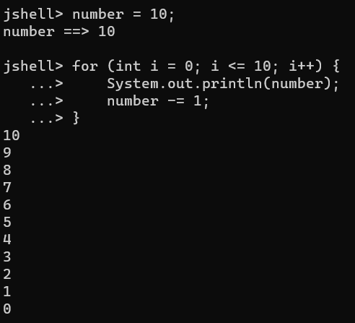 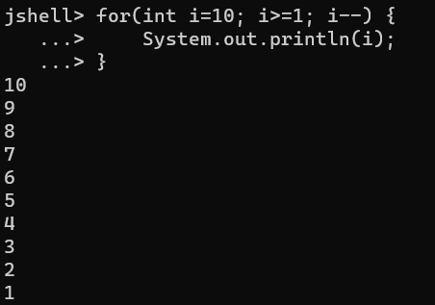

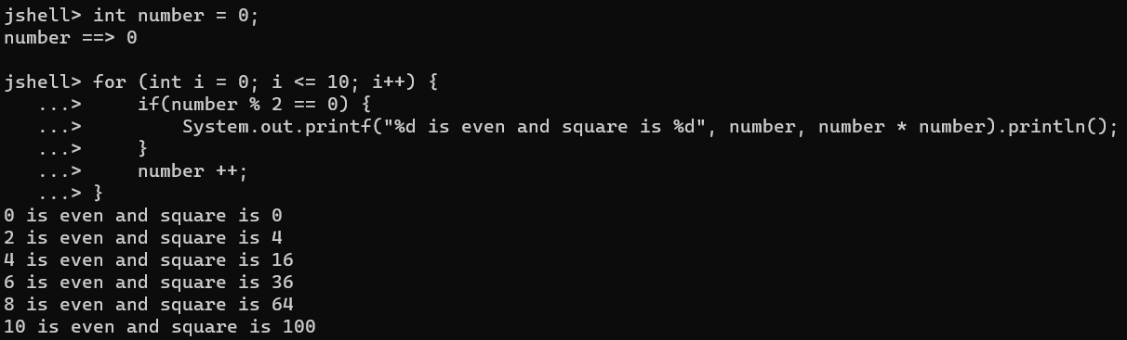

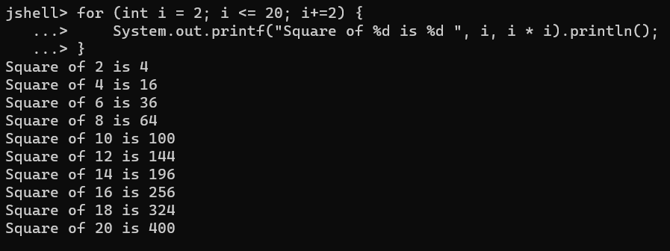

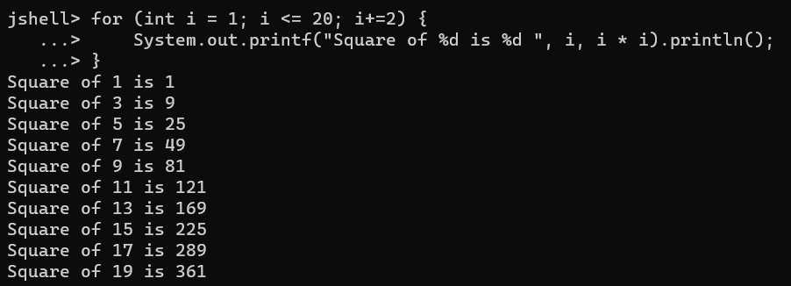

* ***Note:*** *for loop with “;” is an empty* *statement* that means even if we *don’t define* *initialization and update in for loop*, it can *execute statement* and can have *multiple variables but only one condition*. Example: *for( ; i <= 10; i++);* & *for(i=1,j=2; i<=10; i++,j--);* & *for(; ;); 🡪 Infinite loop.*

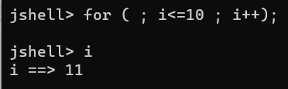 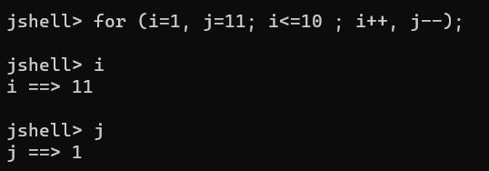

**Method:** It is a block of statements (code), which when called/invoked performs some action. It can be empty or have an argument or passing a parameter.

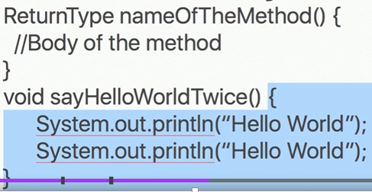 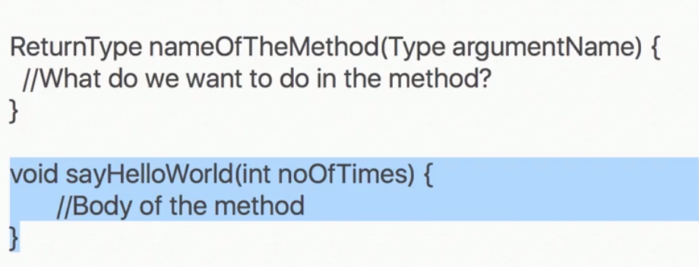

* **Jshell commands:** 
  + - * **/list 🡪** List the variables and methods. Ex: /list sayHello
      * **/save 🡪** Save the variables and methods.Ex: /save sayHello
      * **/edit 🡪** Edits variables and methods in Jshell editor. Ex: /edit sayHello

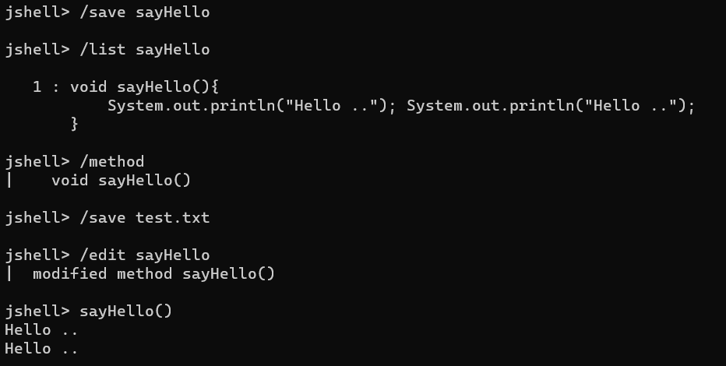

**Challenge 4:** Print square of numbers starting from 1 to n passed as an argument in a method.

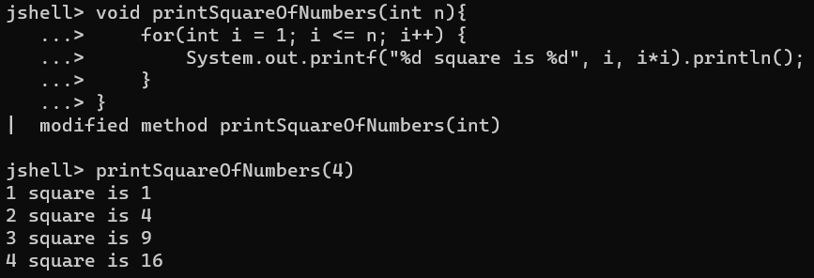

* ***Arguments vs Parameters****:* Arguments are the value passed when calling the method, whereas Parameters are defined inside a method. Ex:

*Argument*

**

*Parameter*

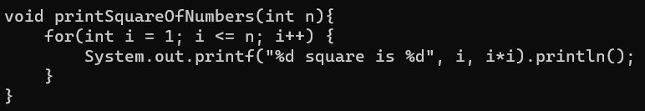

* *Method Overloading:* calling *abc()* and *abc(4)*, *abc(3,4)*. Same method having multiple parameters or arguments.
* *Method with returning value:* Must have a return type and data type defined for method and have only one return value.

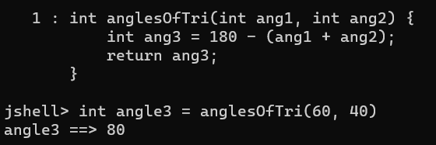

***Java, JRE, JDK***

* *Running a java code*
  + Java code/Java file which when compiled is converted to (.class file) byte code which ran by JVM to achieve platform independency apart from what OS we’re running in.
  + Windows/Linux/Unix JVM converts to OS instructions (0, 1 form) readable by machine.
  + *javac <filename>.java* 🡪 Converts java file .class
  + *java <filename>* 🡪 Runs the .class file

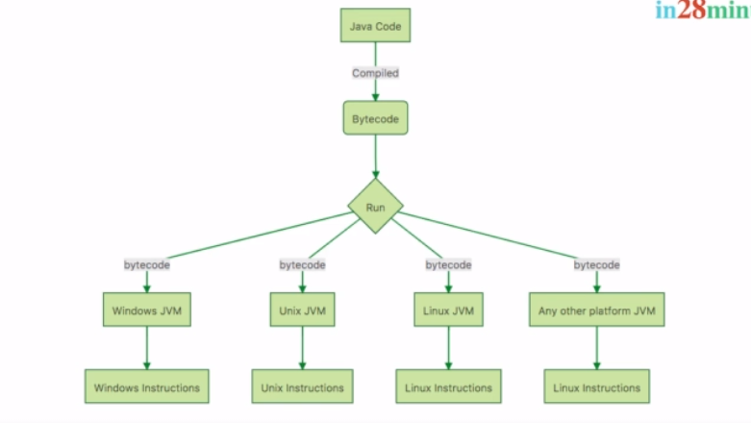

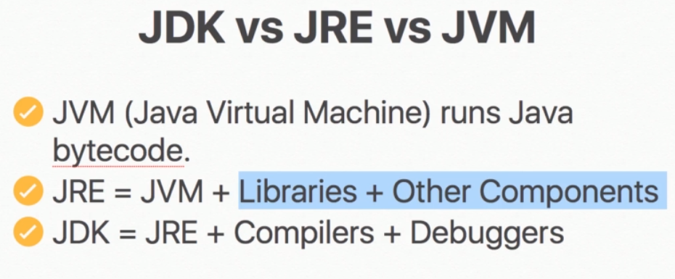

* In case if I am handing over a .class file created on Windows machine to Windows user, I only need JRE on other machine whereas if I am handing over .java file created on Windows machine to Unix user, Unix user will require a JDK, JVM is common in between both and is only used to compile Java file/code to bytecode or .class files.
* Jshell compiles your code automatically, but in case we need to write a code in java file then we need to have a *main() (public static void main(String[] args))* method and compile code every time we make changes in the file.
* *main() (public static void main(String[] args))* method can be empty but it will not do anything, if *no object created or method invoked* in main() method.
* *Code Refactoring :* Code refactoring is a practice to change your code structure in efficient way without changing it’s functionality.

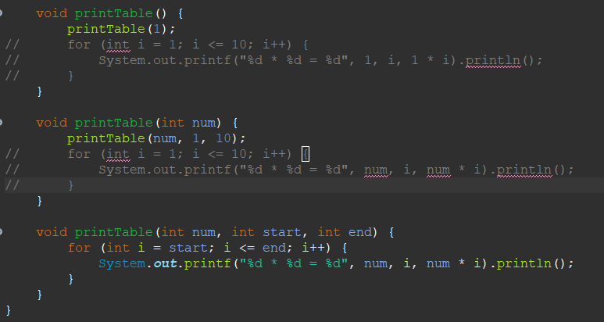

**Object Oriented Programming**

1. C/Pascal is a structured or procedural oriented programming, which is thinking of programming in terms of Structure, Procedure of method. In this we do not think what kind of data or state a method may have.

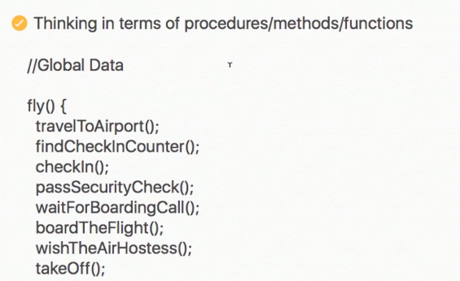

1. In Java structure of programming doesn’t matter, here we think about what kind of method it would be having and data/state of the method and actions it would be performing.

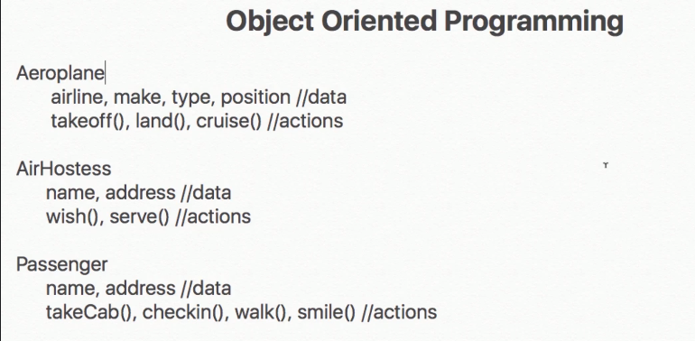

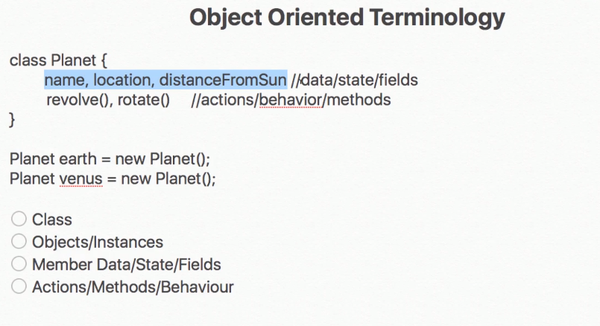

* *Class:* A class is template/blue print which defines like what kind of data it may contain and what will be the behavior/action of it (method) and share common properties and behaviours. For ex: For a planet, it needs to revolve and rotate.
* *Object:* An object is an instance of a class which can vary. For ex: distanceFromSun is different for Earth and Venus.
* *Member Data/State/Fields:* Can vary for each and every instance.
* *Actions/Methods/Behaviour:* Action it needs to perform on it’s object.

*Syntax:*

* *Class- class <ClassName>{}*
* *Object- <ClassName> nameOfObject = new <ClassName>();*
* *Calling method- <nameOfObject>.method_name(arguments);*
* *Calling variable or setting value- <nameOfObject>.variable = value;*

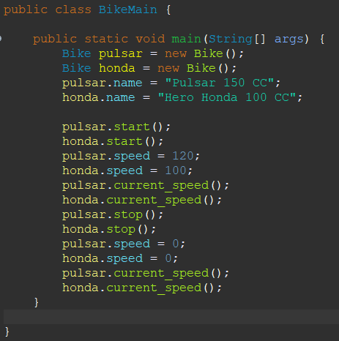

* *private:* Once we make a variable private in a class, it’s value can’t be updated from outer class, which is good practice. The values can be updated using getter/setters or methods and *this* keyword is used to set value of local variable to Member variable.

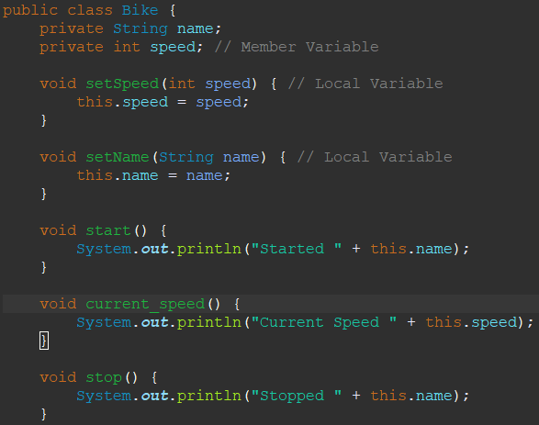 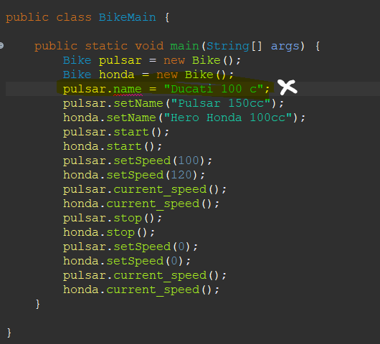

* ***Encapsulation****: Encapsulation refers to the bundling of fields and methods inside a single class. It prevents outer classes from accessing and changing fields and methods of a class.*
  + We can also put validations for *invalid data changes*. For ex: if we set the speed of bike to -100 that should be invalid, what we can do is go into Bike class and put checks for speed > 0.

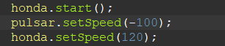 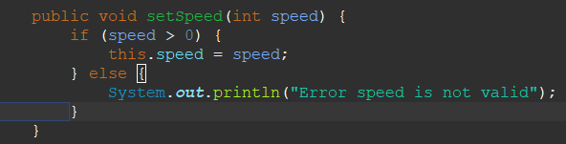

* ***Abstraction****: Abstraction is a process of hiding the implementation details and showing only simplified view to the user.*
* ***Abstraction vs Encapsulation****: Abstraction and encapsulation go hand in hand. Encapsulation is a process of bundling everything in a single entity, whereas abstraction is hiding the complexity of a program.*
* ***Constructor****:* It is method which is used to initialize a variable using objects. It is method having no return type and is same as class name. By default java provides a default constructor but in case if you created a constructor yourself, then the default constructor won’t work and it will throw an error, to resolve this you need to create a empty constructor yourself and invoke other constructors if you want using *this* to initialize value. Important note is *this* can call only one constructor.

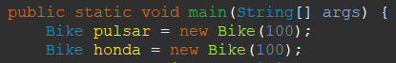 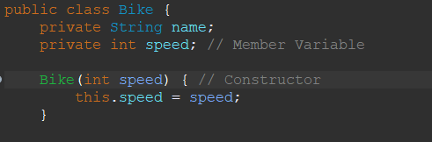

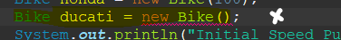 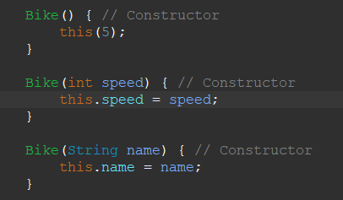

* *Wrapper classes in Java: The wrapper class in Java is used to convert primitive data types into objects. MAX_VALUE, MIN_VALUE, SIZE.*

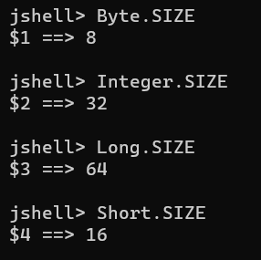

* *Casting: We can only convert lower data type to high data type using explicit conversion. Otherwise Java will automatically convert lower data type to higher data type which is called implicit conversion. Ex :*

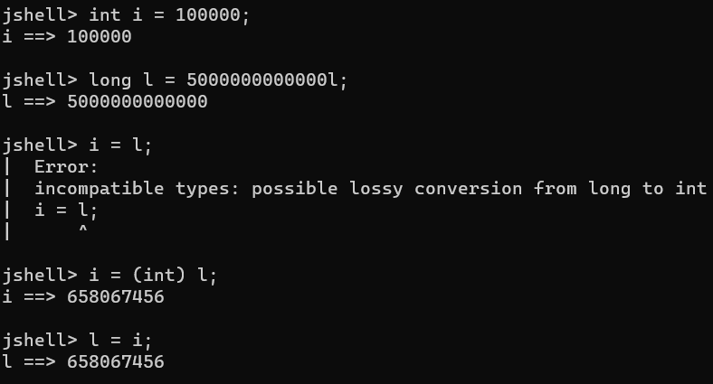

* *Java supports binary, octal, hexadecimal representation. Anything starting with 0, 0x or 0X.* 
  + *Binary – 0 and 1*
  + *Octal – 0,1,2,3,4,5,6 and 7*
  + *Hexadecimal – 0,1,2,3,4,5,6,7,8,9,A,B,C,D,E and F*

*For ex:*

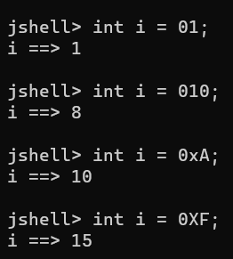

* *Postincrement/Postdecrement: Assignment operator first then increment/decrement.*
* *Preincrement/Predecrement: First increment/decrement then assignment operator.*

*jshell> int j = --i;*

*j ==> 9*

*jshell> i*

*i ==> 9*

*jshell> int i = 10;*

*i ==> 10*

*jshell> int j = i--;*

*j ==> 10*

*jshell> i*

*i ==> 9*

*jshell> int i = 10;*

*i ==> 10*

*jshell> int j = i++;*

*j ==> 10*

*jshell> i*

*i ==> 11*

*jshell> int i = 10;*

*i ==> 10*

*jshell> int j = ++i;*

*j ==> 11*

*jshell> i*

*i ==> 11*

* *BigDecimal:* When we perform arithmetic operations on float and double, result come are inaccurate. It’s good for representation but not for operations, so we use BigDecimal. BigDecimal is a class in java and provide operations as method.

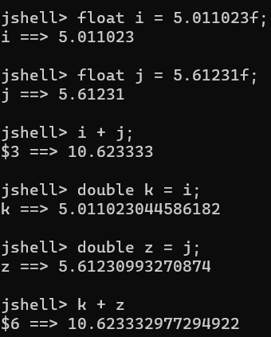

* ***Syntax:*** *BigDecimal <objname> = new BigDecimal(“<decimalnumberasString>”);* If we don’t use String number it will again be not accurate.

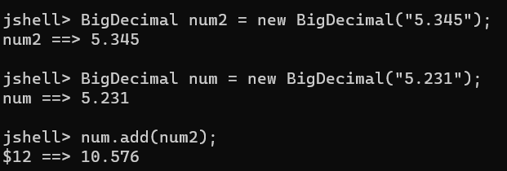

* BigDecimal goes with BigDecimal, otherwise you need to do type conversion using BigDecimal class constructor or import java.math.BigDecimal class.

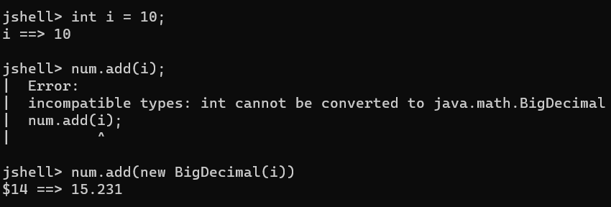

* *Relational Operator :* Result is always Boolean value, true or false.

*&& (AND) 🡪 Both condition needs to be true otherwise will return false. Won’t check both conditions. Notice increment operator won’t changes value first and then compares.*

*|| (OR) 🡪 Either one of condition should be true otherwise will return false. Won’t check both conditions. Notice increment operator won’t changes value first and then compares.*

*^ (XOR) 🡪 Both conditions if different then return true otherwise will return false.*

*& 🡪 Executes for both condition and then evaluate if true, then true otherwise false. Notice increment operator changes value first and then compares.*

*| 🡪 Executes for both condition and then evaluate if either one true then true otherwise false. Notice increment operator changes value first and then compares.*

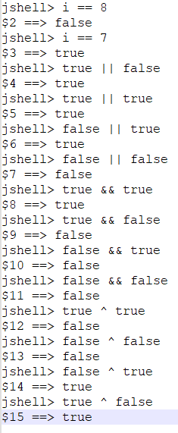 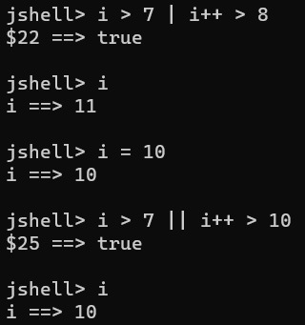 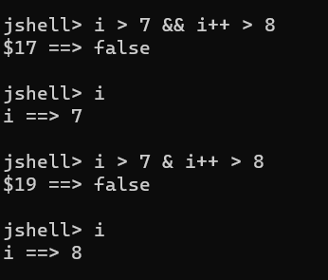

* *Character:* Used to represent a single character. Character in Java supports*, ASCII (65) and Unicode (‘/u0000’)* and we can perform integer operations and typecasting. Remember char is *1 byte* and int is *4 bytes*.
* *toUpperCase(): Character.toUpperCase(ch)*
* *toLowerCase(): Character.toLowerCase(ch)*

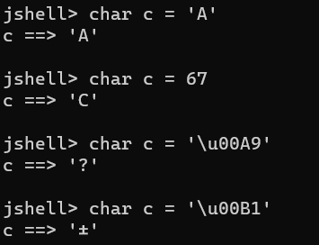 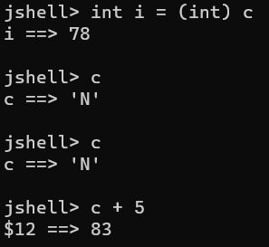

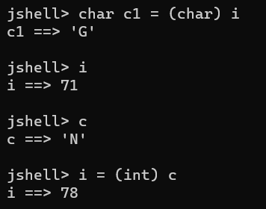

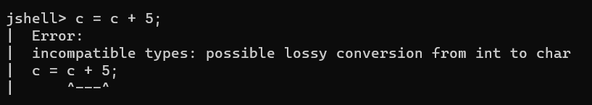

* *To check if a char is digit between 0 and 9, then we need to have AND condition with ASCII values of 0 and 9 char.*

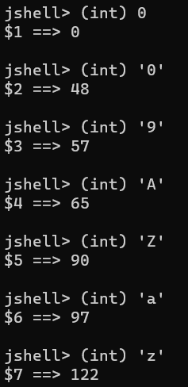

* *Conditional programming:*
  + *If-else: On true execute if statement, otherwise else statement.*

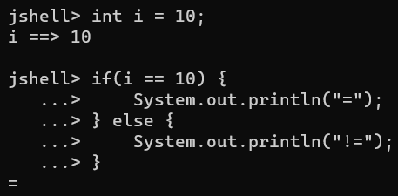

* + *If-else if-else: Only one true condition statement is executed in nested if-else, otherwise else statement.*

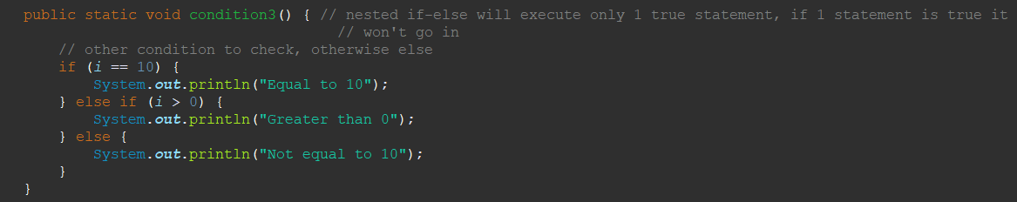

* *Scanner Class: Scanner class is in java.util.Scanner, used for taking user input.*

*Syntax: Scanner <objname> = new Scanner(System.in); //System.in is taking user input*

*int I = <objname>.nextInt(); //takes int value*

* *Switch case: If we don’t put break;, it will execute statements after true onwards. Switch is only applicable for int(short, byte, int), String(char), Enum.*

*Syntax: switch(case) {*

*Case1: <stmt>; break;*

*Case2: <stmt>; break;*

*default: <stmt>;break;*

*}*

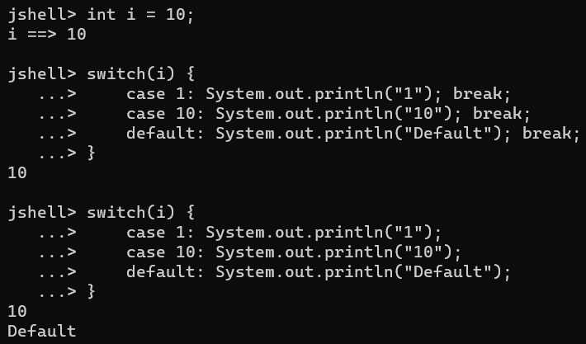

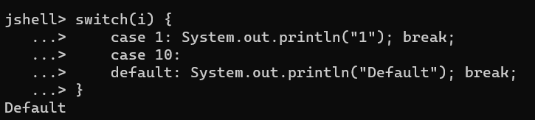

* *Fall through case in switch statement is if we didn’t defined case statement, then it will execute till next break and return statement. In case if we put return, defining break is not mandatory.*

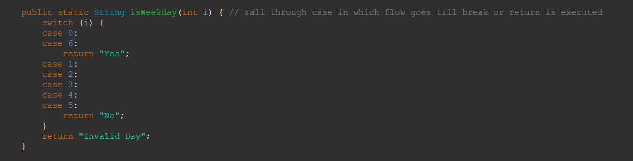

***Loops***

* *Loops are used to run same code again and again based on condition.*
* ***For Loop****: It is not mandatory to have initialization, condition or update to be provided in for loop. It can still execute the code.*

*Syntax: for(initialization; condition; update) {<Stmt>}*

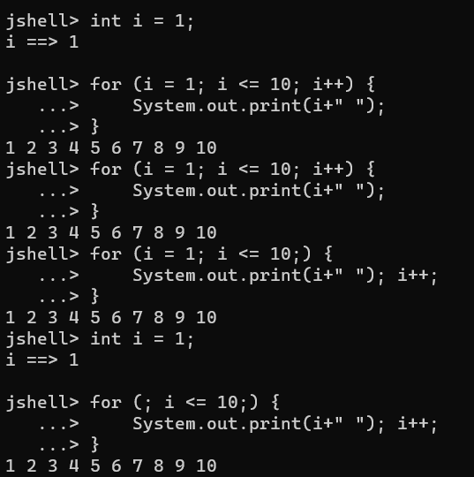

* ***While Loop:*** *While will execute statement till it’s condition is true, once false it exits.*

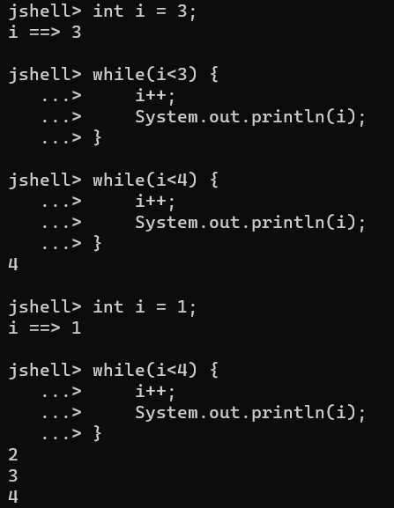

* ***doWhile Loop:*** *Condition check is at last in do-while loop. Statement in do block will at least be executed once since condition is checked at last.*

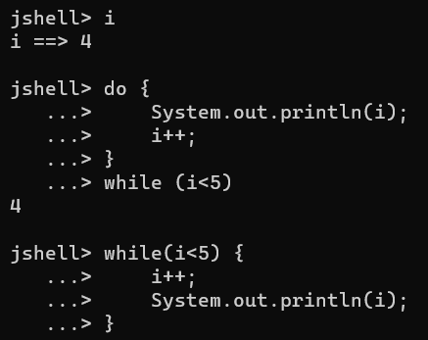

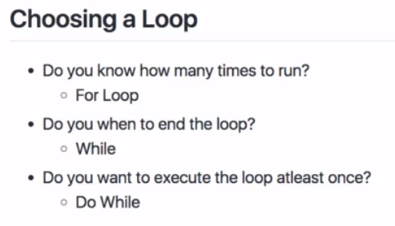

* ***Ternary Operator:*** *condition? <stmtfortrue>: <stmtforfalse>. <stmt> should be of same data type.*

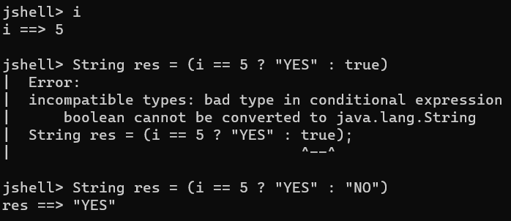

* ***Break vs Continue:*** *Break will exit out of loop once condition is false. Continue will continue executing next statement but will skip the condition where it fails.*

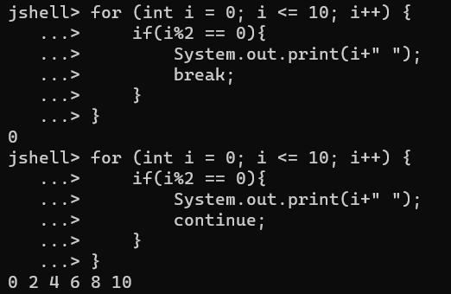

* ***Reference Type and Reference Variables:*** *Any class is reference type and it’s objects are reference variables, variables created are primitive data type.*

*Each method is stored in a Stack memory and objects are stored in Heap memory. For primitive data type values can be compared on basis of values, whereas for reference variable to be equal, they need to have same memory reference.*

|  |  |
| --- | --- |
| Location | Object |
| *1A* | *Animal12* |
| *1B* |  |
| *1C* | *Animal15* |
| *1D* |  |

|  |  |  |
| --- | --- | --- |
| Location | Value | Var |
| *A* | *5* | *i* |
| *B* | *1A* | *dog* |
| *C* | *1C* | *cat* |
| *D* | *1C* | *cow* |

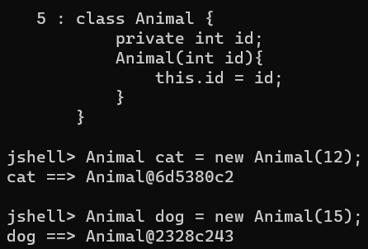

Heap

Stack

* *cow = cat (Reference location is copied into value and are equal, Since Object variable they’re referring to same object)*
* ***String:*** *String is a special class in java and an object to store character sequences.*

*Ex: String str = “<Value>”*

*String str = new String(“<Value>”);*

***Operations on String:***

1. *Str.length() 🡪 Gives length of String*
2. *Str.charAt(i) 🡪 Gives char at the index value*
3. *Str.substring(I,j) 🡪 Gives characters b/w start index and last index.*
4. *Str.equals(“str”) 🡪 true/false matching case string if equal.*
5. *Str.equalsIgnoreCase(“str”) 🡪 true/false w/o matching case if equal.*
6. *Str.lastIndexOf(“str”) 🡪 returns last occurrence index of char in string.*
7. *Str.indexOf(“str”) 🡪 returns first occurrence index of char in string.*
8. *Str.startsWith(“str”) 🡪 true/false if string is starting with matching string.*
9. *Str.endsWith(“str”) 🡪 true/false if string is ending with matching string.*
10. *Str.concat(“str”) 🡪 Adds string at end.*
11. *Str.contains(“str”) 🡪 If string contains the string.*
12. *Str.toLowerCase(“str”) 🡪 Converts String to lower case.*
13. *Str.toUpperCase(“str”) 🡪 Converts String to upper case.*
14. *Str.join(i,j,k) 🡪 String will join first char with other char separated via ‘,’.*
15. *Str.replace(“st1”,“str”) 🡪 Replaces string with next string value.*

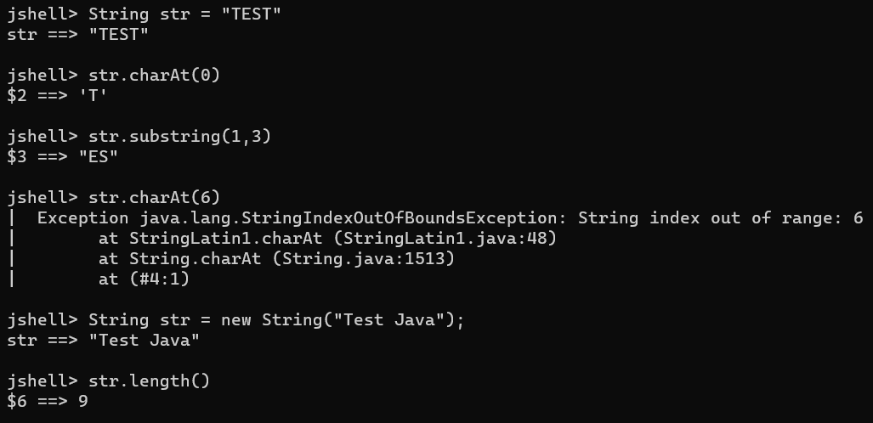

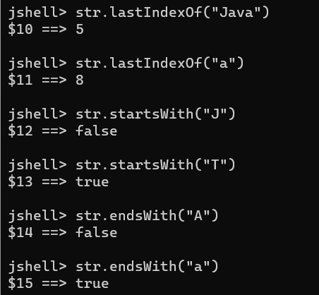 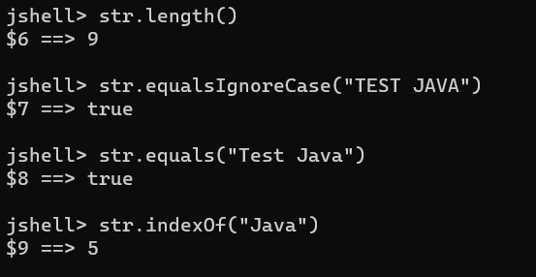

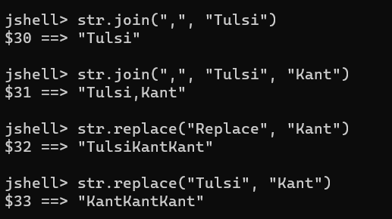

* ***Immutable String:*** *String is immutable in java, which means it’s value can’t be updated in same String object. The string previous values will remain same as it is in heap memory, since String is an object but a new String object will be created with values pointing to old String reference.*

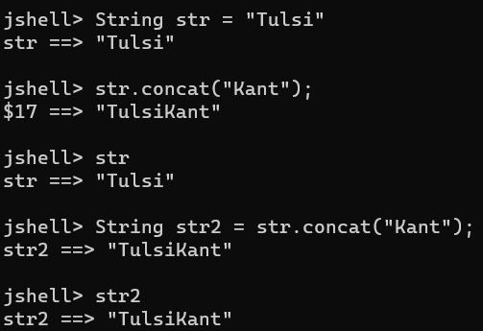

* ***If string is + with integer the result will be string as + will behave as concatenation then.***

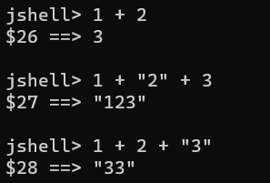

* ***String Buffer/String Builder:*** *String Buffer and String Builder is mutable. String buffer is not thread safe and not recommend for multiple strings whereas String builder is thread safe.*
* ***Syntax:*** StringBuffer sb = new StringBuffer(“Str”);

StringBuilder sb = new StringBuilder(“Str”);

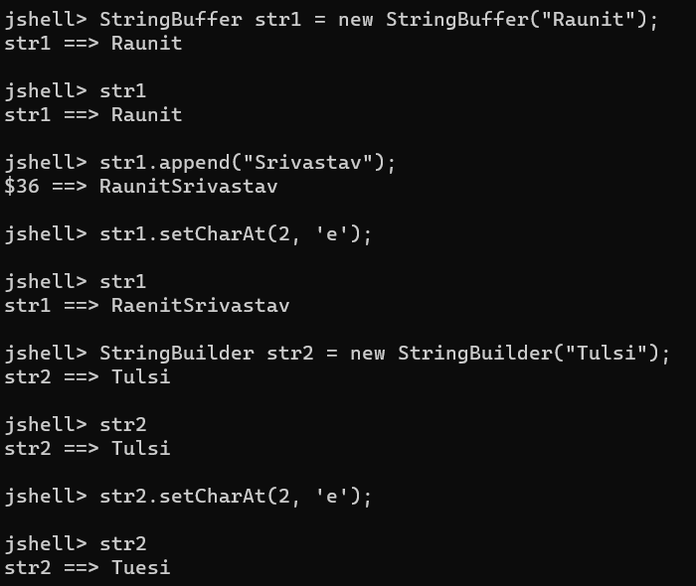

* ***Wrapper Classes:*** Wrapper classes offer more options than primitive classes. Ex: *valueOf(),MAX_VALUE,MIN_VALUE,BYTES,SIZE. Deprecated now.*

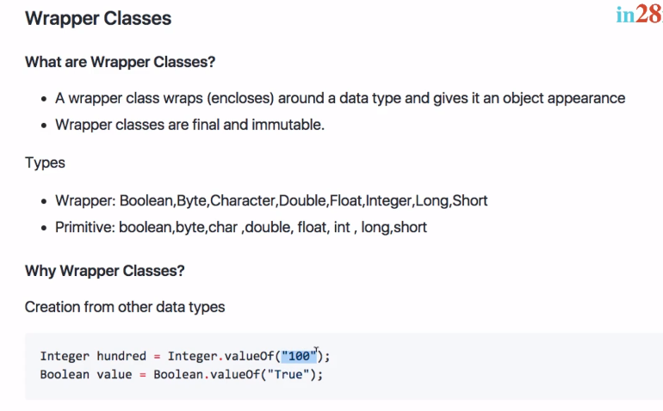

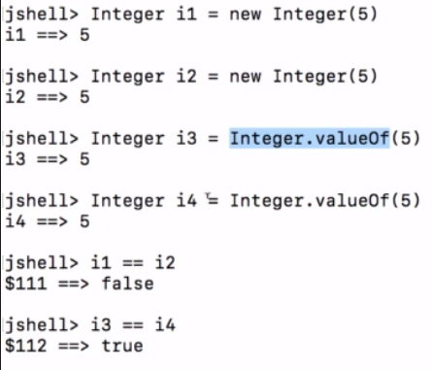 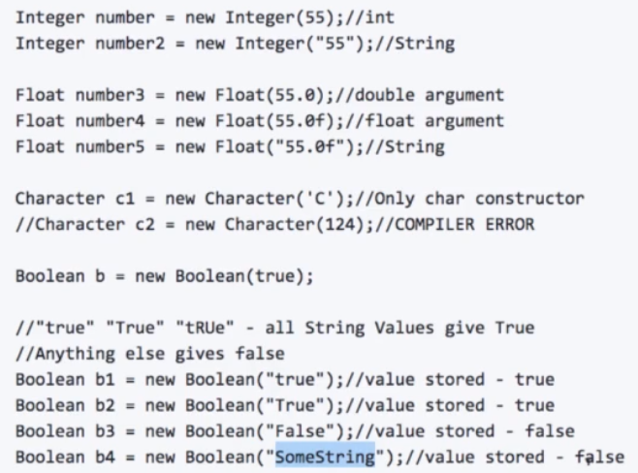

* ***LocalDate, LocalDateTime, LocalTime:*** *Returns current date, time, date and timestamp.*

Syntax: *LocalDate today = LocalDate.now();*

*LocalDateTime today = LocalDateTime.now()*

*LocalTime time = LocalTime.now()*

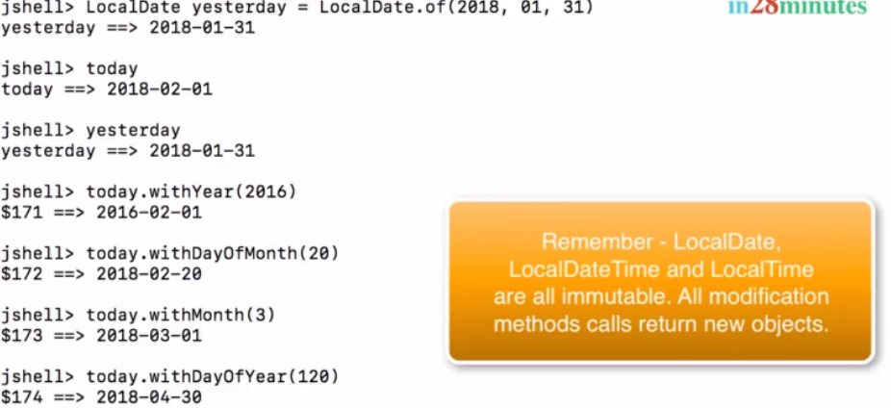

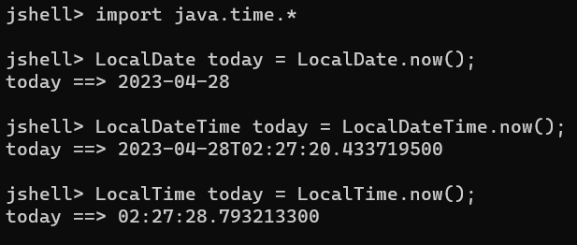

* ***Arrays:*** *Arrays are used to store same data type elements. Array can contain 0 element or N elements in it. Length of array is 0 to N-1.*

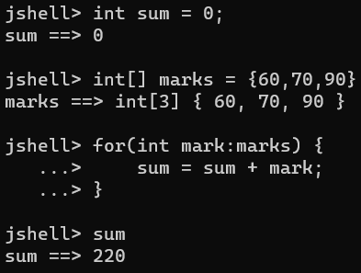 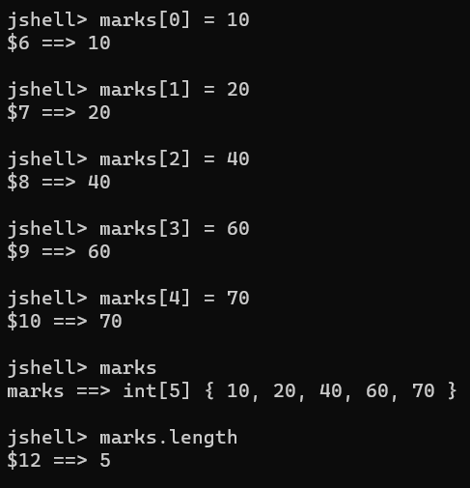

* ***Accessing/Reading Array elements:*** Loop for the array elements. If we need to print array on console, we can use *System.out.println(Arrays.toString(<arr>));* as well.

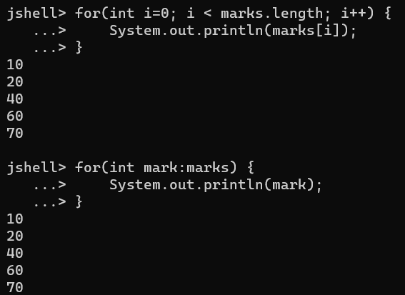

*Array storing class*

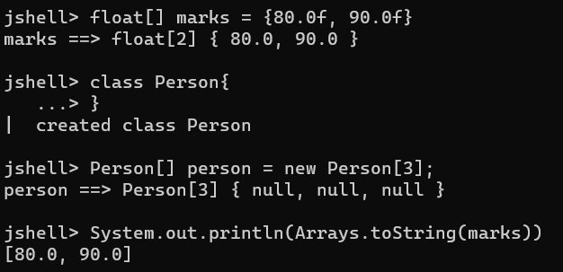

* ***Arrays Operation:*** 
  + *Arrays.toString(<Arr_Name>):* Use to print array in console.
  + *Arrays.fill(<Arr_Name>,<Value>):* Fills all array elements with same value.
  + *Arrays.equals(<Arr_Name1>,<Arr_Name2>):* Compares two arrays if equal or not.
  + *Arrays.sort(<Arr_Name>):* Sort all arrays elements in ascending order.

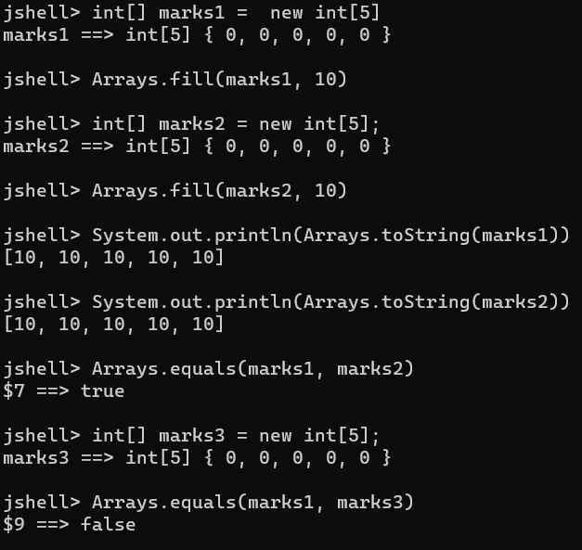 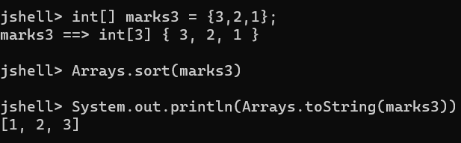

* ***BigDeciamal RoundingMode.UP/DOWN:*** BigDecimal if values is like 9.66666676676 🡪 It can be rounded up like *(new BigDeciamal(num, pos, Mode)).* 
  + ***UP 🡪*** Means the decimal will be rounded to upper value. Ex: 9.666667 🡪 9.66.
  + ***DOWN 🡪*** Means the decimal will be rounded to lower value. Ex: 9.666667 🡪 9.67.

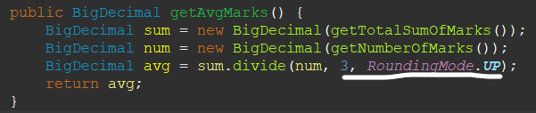

* ***Variable Arguments:*** In case we don’t have exact max length of parameters to be defined, we can user Variable arguments. Variable arguments should be the last parameter defined in method. Variable arguments are treated as arrays. Ex: int… marks

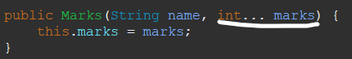



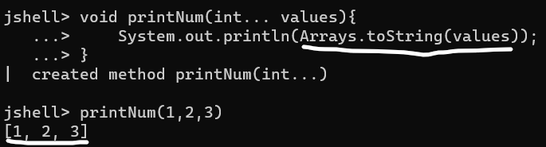

* ***ArrayList:*** Arrays have fixed size, whereas ArrayList has dynamic size. Adding and removing in array is complex process and only way is to copy elements to new array and add/remove element in new array. So the concept of arraylist comes into picture.

***Syntax:*** *ArrayList<DataType> name = new ArrayList<DataType>();*

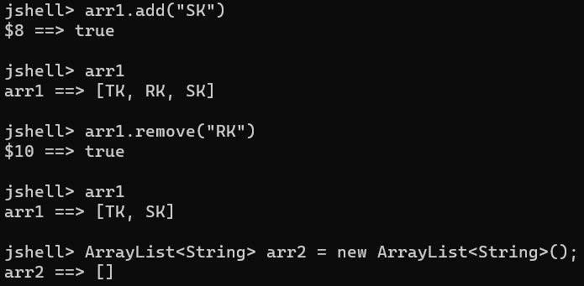

* ***Note:*** *If arrayList is Integer type then it will remove at index and not element. To remove element we need to typecast it as.*

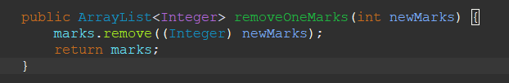

***OOPS***

Objects have state (values) which changes accordingly, variables are member variables of a class and methods changes the behavior of an object.

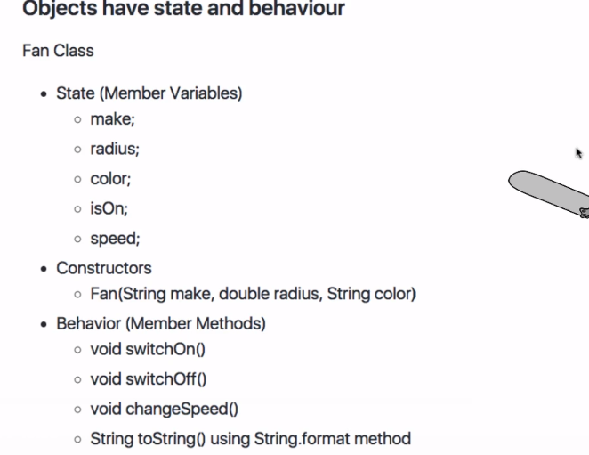

* ***Object Composition:*** When an object contains reference of another object, it’s called object composition or in simple words. A class having object of another class within it and an object created for the class.

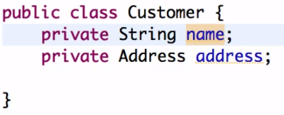

* ***Inheritance:*** Inheriting the property of another class is called Inheritance, inheritance reduces code duplication and increase code reusability. *Subclass extends Superclass* and when subclass object is called it gets all properties of Superclass variables and methods.
* ***Object class is at top of inheritance:*** Every class in java *extends Object class. Java by default extends class Object for methods like toString(), hasCode() e.t.c. If we use our toString() method we’re overriding the method of default Object class.*
* ***Method Overriding:*** Method overriding is a process in which a subclass can override or implement method of a Superclass. *First superclass constructor gets called then subclass constructor.*
* *If we create a constructor in super class and in subclass extending it. It will throw error Implicit super constructor SuperPerson() is undefined. Must explicitly invoke another constructor. So we need use super keyword along with parameter we need to pass to superclass. Java by default creates a constructor with super().*

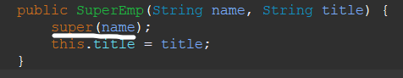

* ***Java doesn’t allow multiple inheritance as it complexes the process of inheritance. But we can have superclass, subclass, innersubclass… and a superclass having multiple subclass, which is called inheritance chaining. We can use instanceof to know if subclass is an object of a superclass or not.***

*Multiple Inheritance*

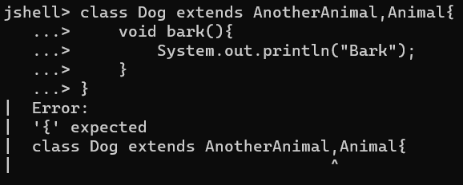

*Inheritance Hierarchy*

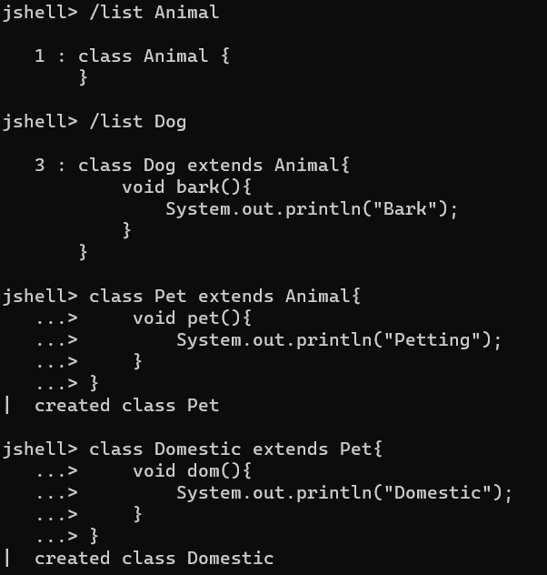

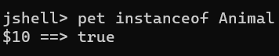

* ***Abstract Class:*** *Abstract class only contains implementation and not body of any method, the empty body of abstract class mandatory to be implemented by it’s subclass when extended. We can’t create object of an abstract class. Abstract class will have abstract methods only. Abstract can have no methods as well. Abstract class can have variables and methods with implementation but since object can’t be created for abstract class, subclass object can call the method of abstract class.*

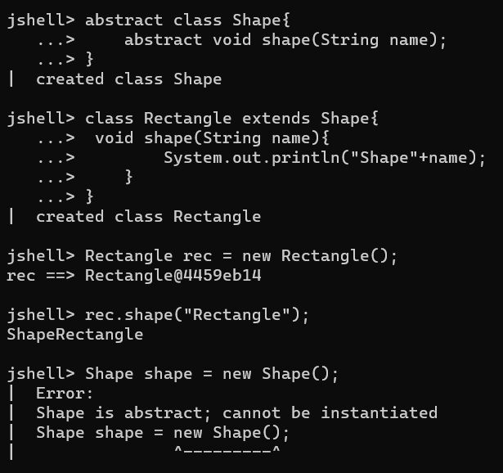 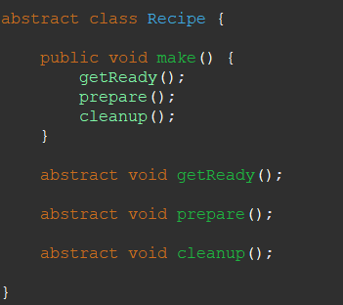

* ***Interface:*** *Interface in many terms is similar as that of abstract class, it is also used to define unimplemented methods, which then once implemented by subclasses methods.*

*In interface we can use Superclass object along with subclass objects as well. Interface keyword is used to represent interface class and implements keyword by subclass to implement superclass methods.*

*Interfaces in practical scenario can be used if any dummy implementation we have we can use for now, but in future if someone designs real implementation, then all we need to do is change in object to new class object, which makes easy to implement.*

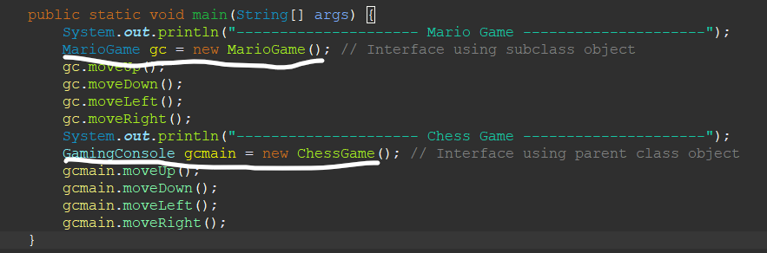

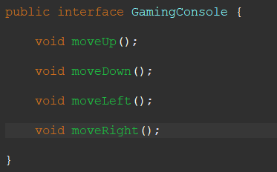

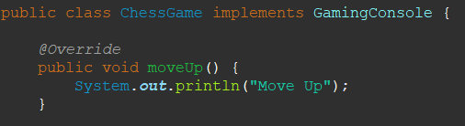 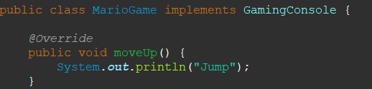

* ***Can interface have variables?*** *No, it needs to be defined value.*

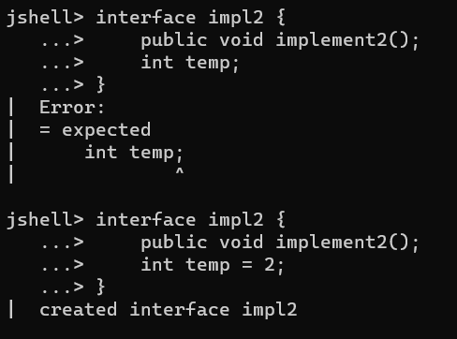

* ***Can interface have normal method?*** *No normal methods are not allowed,**We can use default keyword before method to have default implementation in interface.*

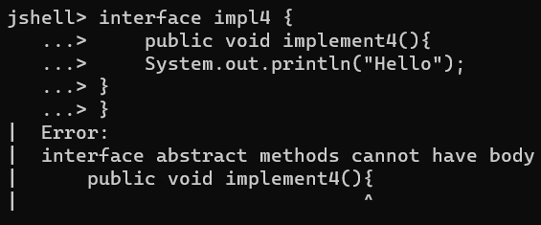 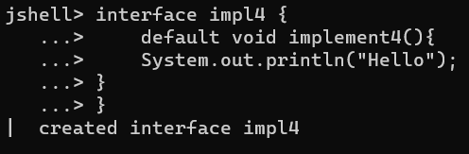

* ***Can interface extends each other?*** *Yes, but if a subclass(3rd) is implementing extending interface, it needs to implement both interface methods.*

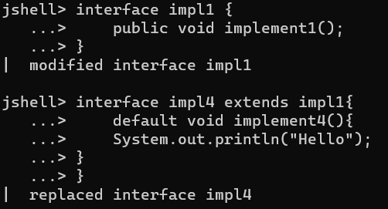 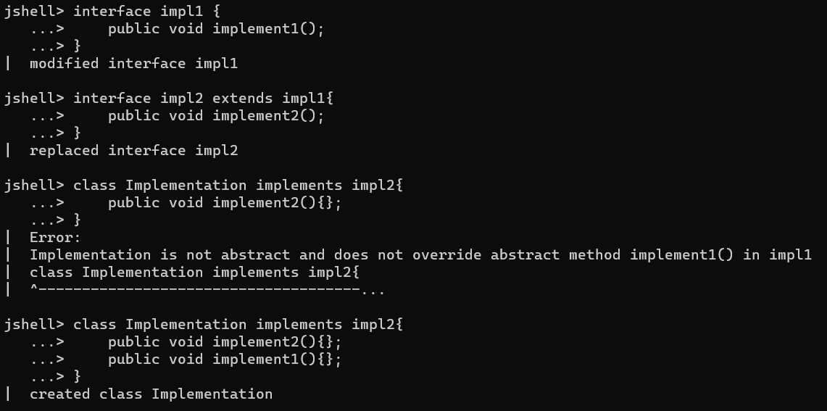

* ***What if when extending interface I need to implement only one interface method and not of other interface?*** *We can use abstract method in that case.*

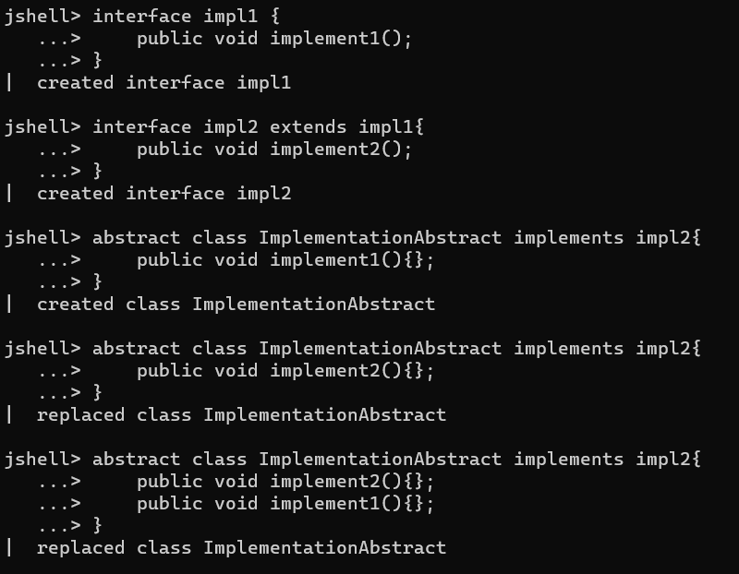

* ***Can we override default method of an interface when implemented?*** *Yes we can.*

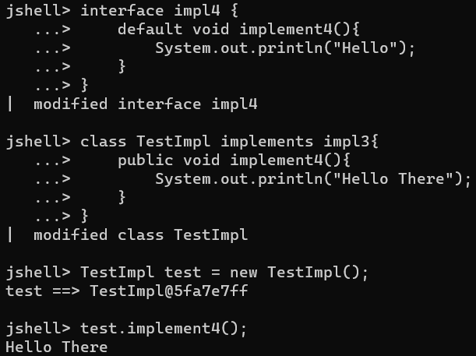

* ***Abstract class vs Interface:*** 
  + *Abstract class can have variables with different values, but in interface values are constant.*
  + *Abstract class can have all types of variable/methods whereas in interface variable/methods should be public it can’t be private.*
  + *All Abstract class methods need to be implemented by it’s subclass, but in interface the class implementing it does not need to implement all methods.*
  + *Multiple Abstract class cannot be extended, whereas multiple interfaces can be implemented.*
* ***Polymorphism:*** *Same code with different behavior based upon input. Interface and Abstract classes by default uses concept of polymorphism. Ex: For Dog class bark method prints “Bow Bow” but for Cat class same method prints “Meow Meow”.* 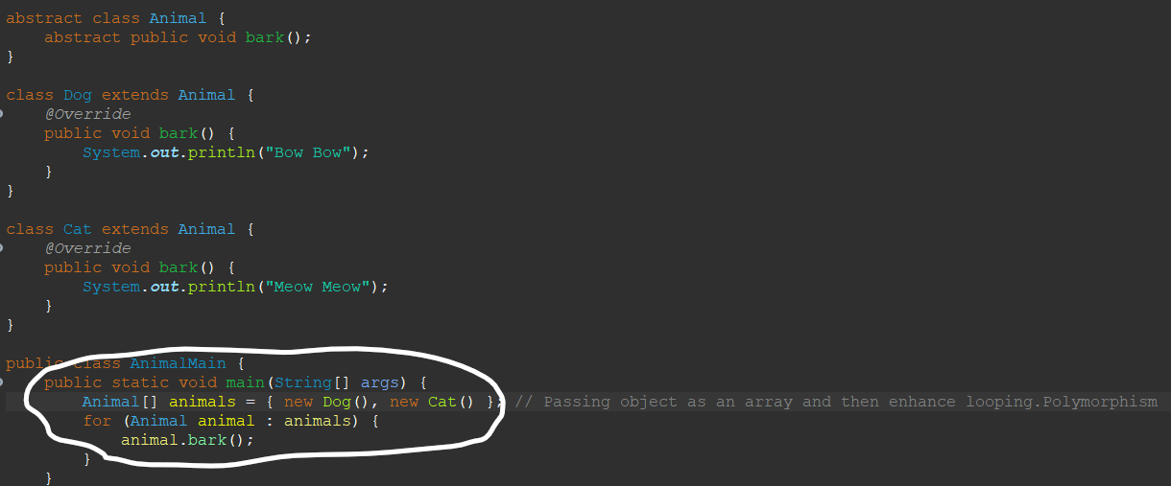
* ***Collections:*** *Modifying array is difficult, if we need add/remove any element. We need add/remove subsequent element and then copy elements into new array. Hence, comes the concept of Collection.*

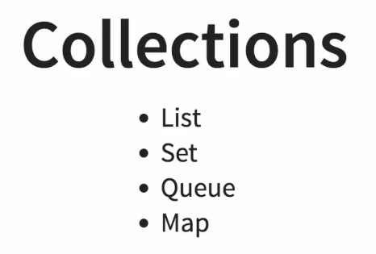

* ***List:*** *It stores same data types and can have duplicate elements. ArrayList, LinkedList, Vector.*

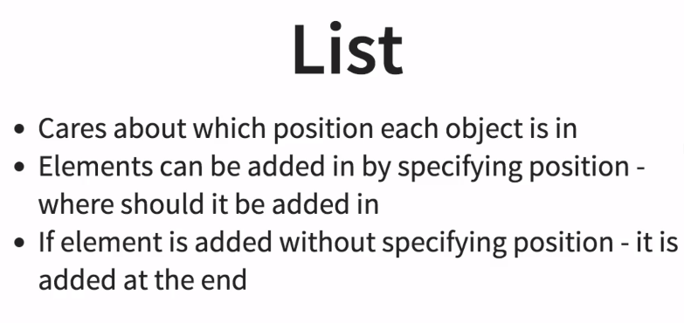

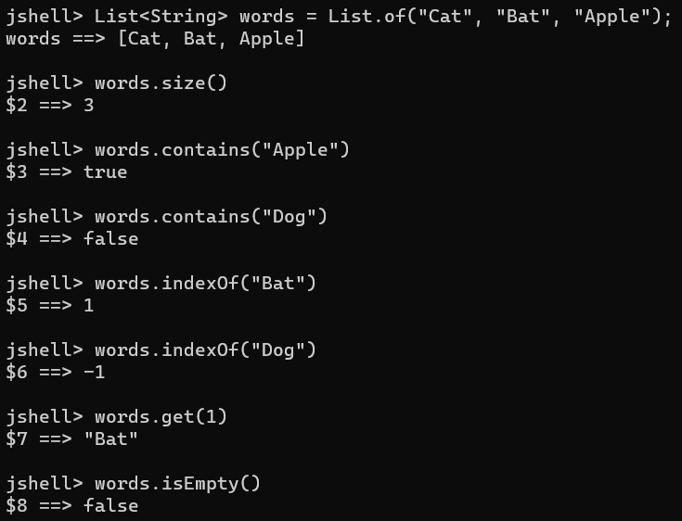

* Anything created with *List.of* is immutable, means we can add values. So we can create *ArrayList, LinkedList and Vector which are mutable.*

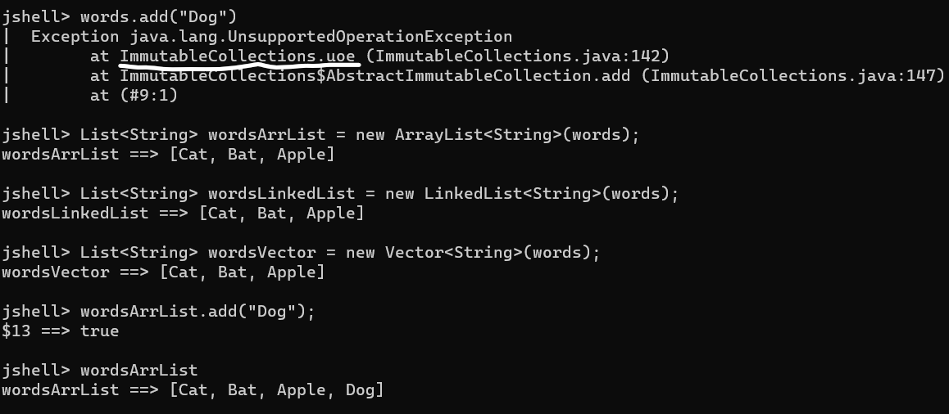

* ***ArrayList vs LinkedList vs Vector:*** 
  + *In ArrayList base is array so iterating is easy in array list whereas In LinkedList base is linkedList so iterating is complex since each element is linked to one other and if we need to find any element as specific position we need to start from linkedList top.*
  + *In ArrayList insertion and deletion is time taking and not very efficient, whereas in LinkedList insertion and deletion is easy since elements have reference to one another.*
  + *Vector was implemented before ArrayList and is much more synchronized and threadsafe than ArrayList (Only one thread can access Vector elements)*
  + *ArrayList & Vector in terms of operations but the difference is in threads.*

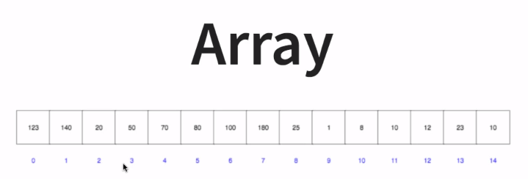 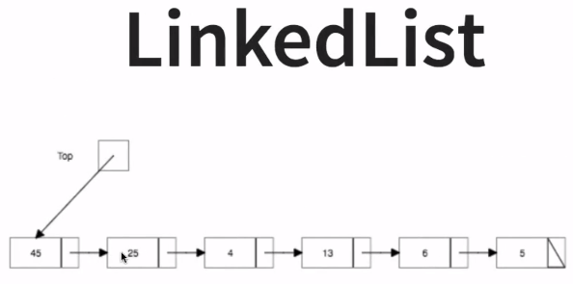

* ***Operations on List:***
  + *arr.add(i, <ele>) 🡪 Adds an element at an index, if index not given, it’ll add at end.*
  + *arr.remove(i, <ele>) 🡪 Removes an element at an index, if index not given, it’ll remove element specified.*
  + *arr.set(i, <ele>) 🡪 Sets an element at particular location or remove element at that location.*
  + *arr.addAll(<arr>) 🡪 Add a new list elements to previous list at the end.*
  + *arr.get(i) 🡪 Gets an element at an index.*
  + *arr.contains(<ele>) 🡪 Check if element specified contains in the list.*

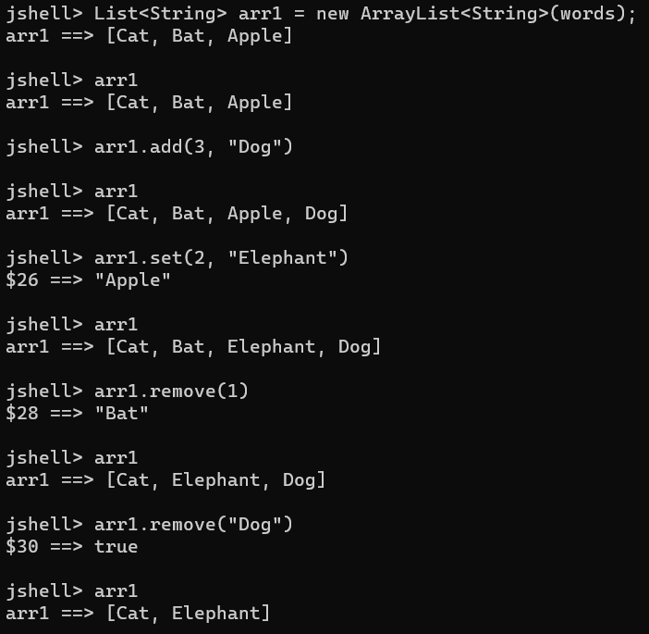 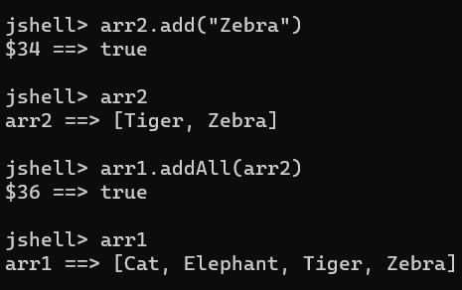

* ***Iterating over list:*** 
  + *Using for loop*
  + *Using enhanced for loop (For viewing it’s good, for removing it’s not as enhanced for loop doesn’t make changes to last element as it may hamper the structure of list 🡪 Go with iterator)*
  + *Using Iterator*

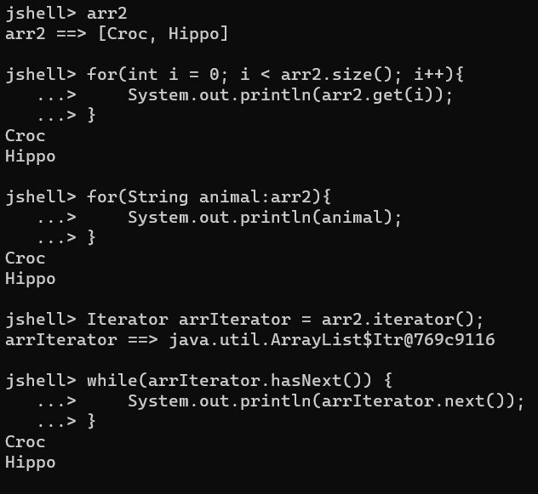

* ***Removing element in List:***

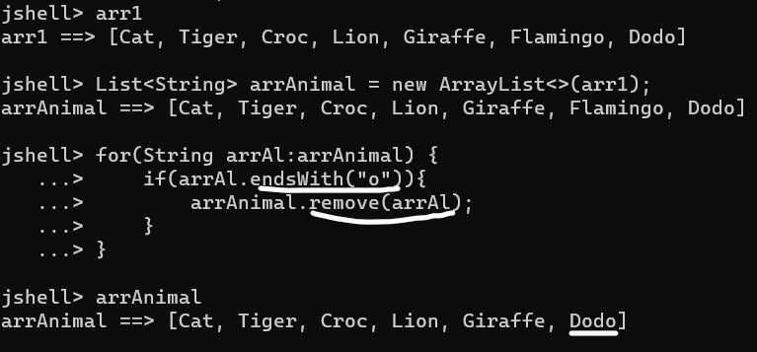

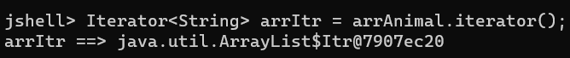

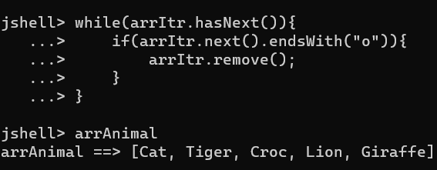

* ***Complex things for a List:*** 
  + If we don’t generalize type of list it can store any value. *Primitive data types are not stored in List, so it boxes all the elements into it’s wrapper classes (Auto Boxing).*

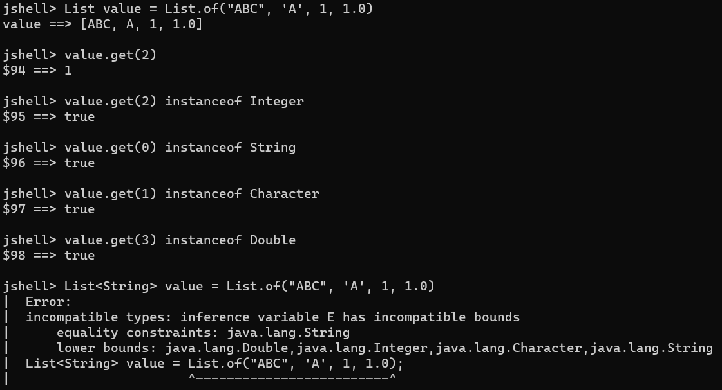

* + *remove method accepts 2 formats only object and index, use wrapper of Integer.*

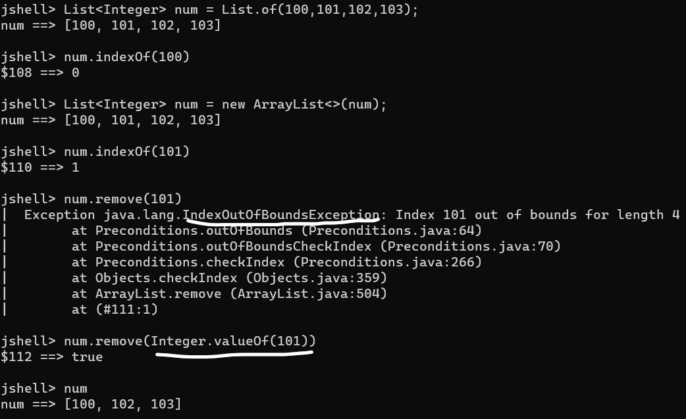 

* ***Sorting:*** Sorting can be done for Integer using *Collections.sort(<arrList>)* but in case we need to compare an *object of a class* then we need to *implement* *Comparable<>/Comparator<> interface in our class* and then *implement* *compareTo()/compare() method* in our class.

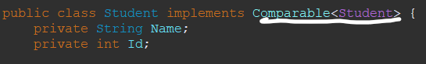

***Ascending Descending***

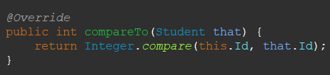 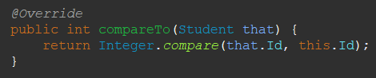

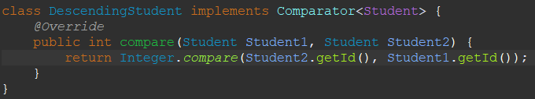

* ***Set:*** *Set has unique elements and doesn’t store any duplicate values. Set doesn’t store elements in same order.*

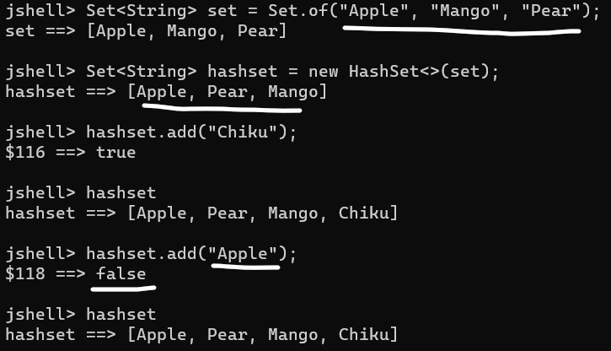

* ***Hash:*** *Hash table makes search easy as it uses Hashing table function. Faster than array.*

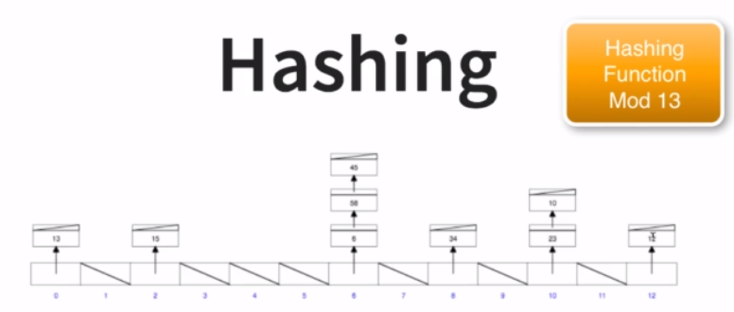

* ***Tree:*** *Tree stores data in sorted manner, left will have small elements whereas right will have larger elements. Sorting in tree is easy, as well as insertion, deletion and iteration is not so much time taking or costly.*

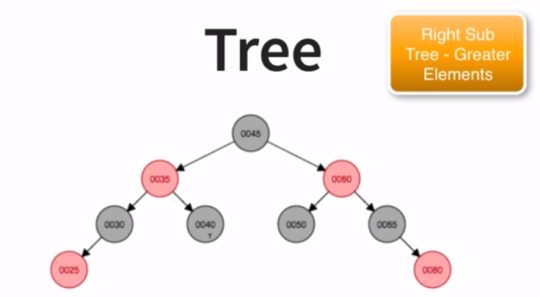

* ***Hashset, LinkedHashSet, TreeSet:*** *All three will not have any duplicate values.*
  + ***Hashset:*** *Hashset elements will have no duplicates and not in order.*

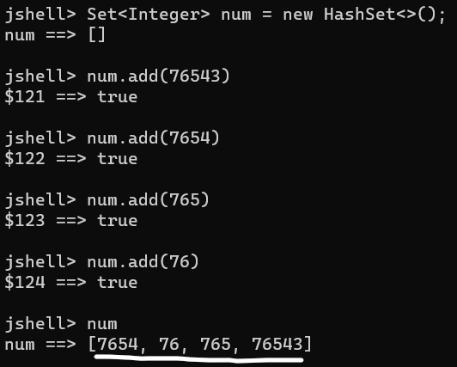

* + ***LinkedHashSet:*** *LinkedHashset elements will have no duplicates but in order they were inserted.*

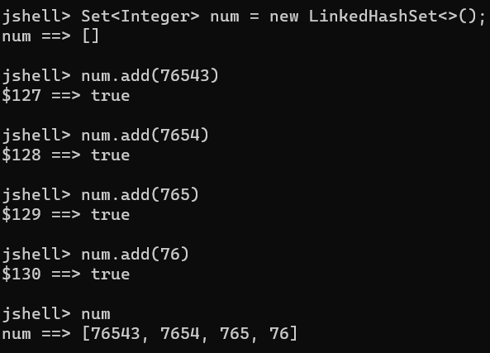

* + ***TreeSet:*** *TreeSet elements will have no duplicates but be in sorted way.*

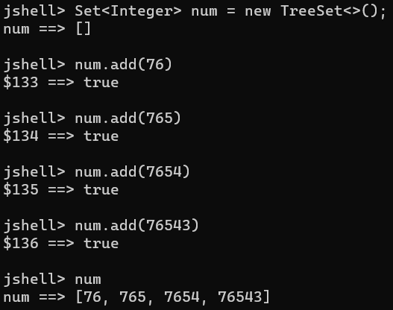

* ***Tree Operations:*** Operations are specific to TreeSet as data is sorted.
  + *tree.floor(<ele>) 🡪 Lower value than <ele> in a treeset.*
  + *tree.ceiling(<ele>) 🡪 Higher value than <ele> in a treeset.*
  + *tree.lower(<ele>) 🡪 Equal/Lower value than <ele> in a treeset.*
  + *tree.higher(<ele>) 🡪 Equal/Higher value than <ele> in a treeset.*
  + *tree.subSet(<ele1>,true,<ele2>,true) 🡪 If true including <ele1/2> return number in between in a treeset.*
  + *tree.headSet(<ele>) 🡪 All elements before <ele> in a treeset.*
  + *tree.tailSet(<ele>) 🡪 All elements after <ele> in a treeset.*

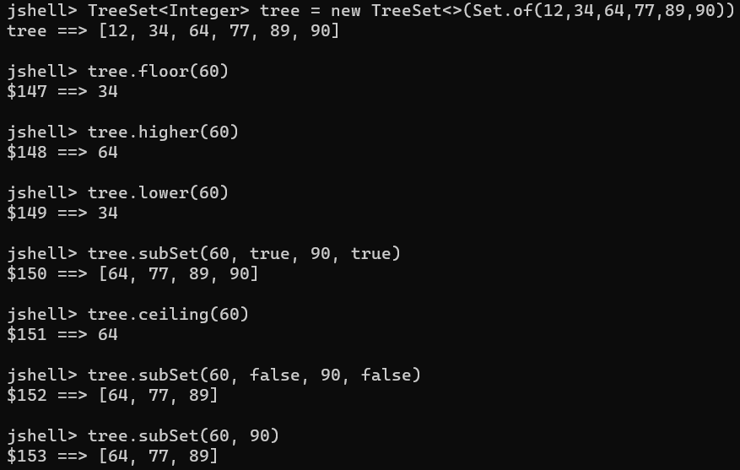

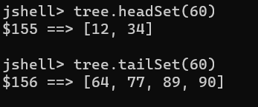

* ***Queue/PriorityQueue:*** *Queue stores elements based on priority in Java.*
  + *Q.poll() 🡪 Gets next element.*
  + *Q.add(<str>) 🡪 Adds an element in a queue.*
  + *Q.addAll(<list>) 🡪 Adds all elements in a queue.*
  + *Q.offer(<Str>) 🡪 Insert new element in a queue.*

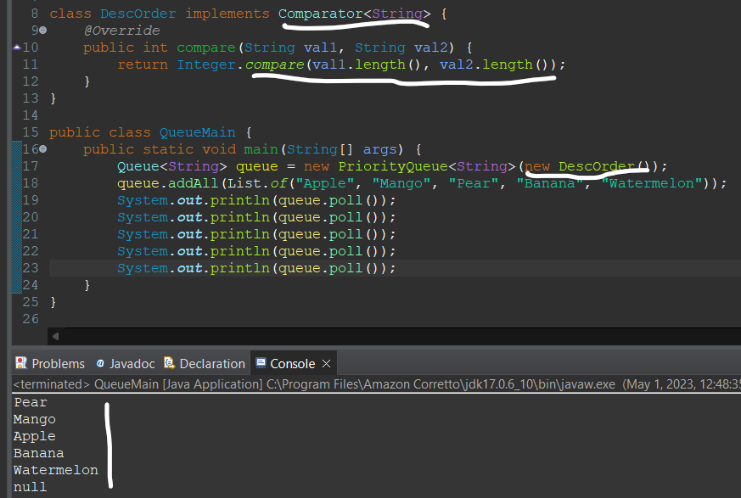

* ***Map:*** Map is a part of collection, *but doesn’t extend/implement collections class like List, Set and Queue. It stores in a key, value pair.*
* ***Types:***

*1.* ***HashMap*** *🡪 Unsorted, Unordered, Allow value null.*

*2.* ***HashTable*** *🡪 Unsorted, Unordered, Does not allow value null, thread Safe.*

*3.* ***LinkedHashMap*** *🡪 Stored in order given, slower insertion/deletion, faster iteration.*

*4.* ***TreeMap*** 🡪 *Sorted, Implements navigableMap.*

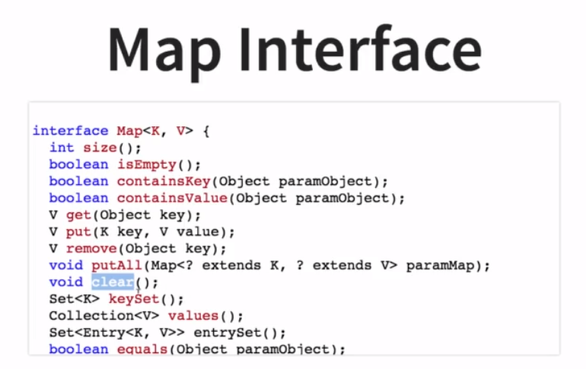

* + *map.get() 🡪 Gets key value in a map.*
  + *map.size() 🡪 Gets size of map.*
  + *map.containsKey(“K”)/map.containsValue(“V”) 🡪 Checks if key/value is present in map.*
  + *map.keySet() 🡪 Gets set of keys in a map.*
  + *map.values() 🡪 Gets values in a map.*
  + *map.isEmpty() 🡪 Checks if map is empty or not.*

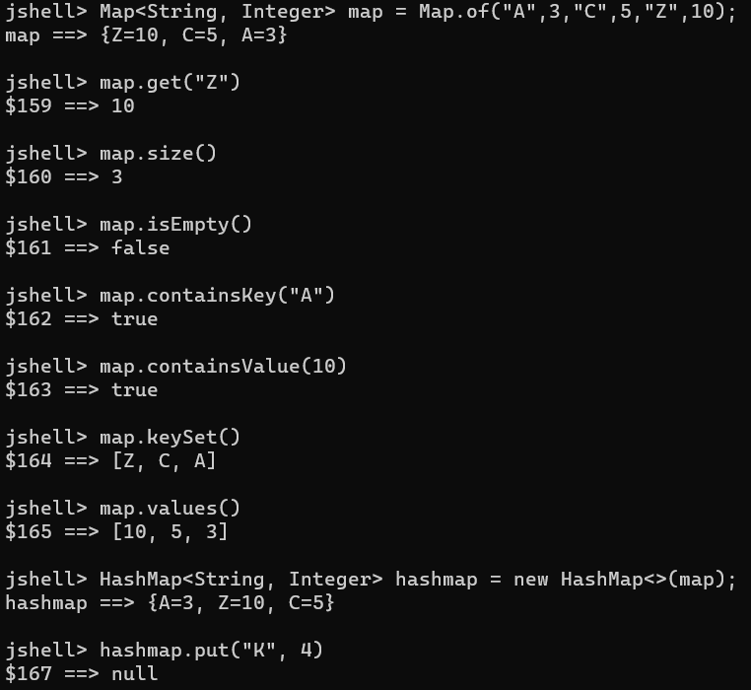

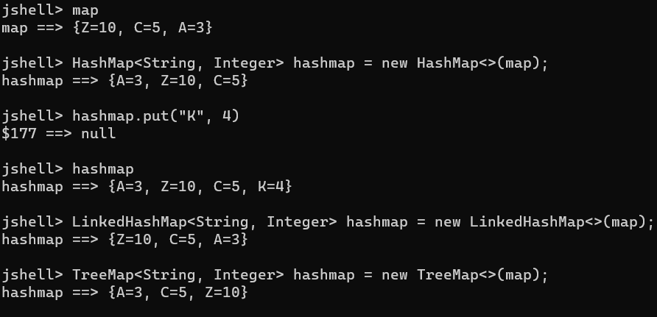

***Challenge 5:*** *Find occurrences of a character and String in a long String using Map.*

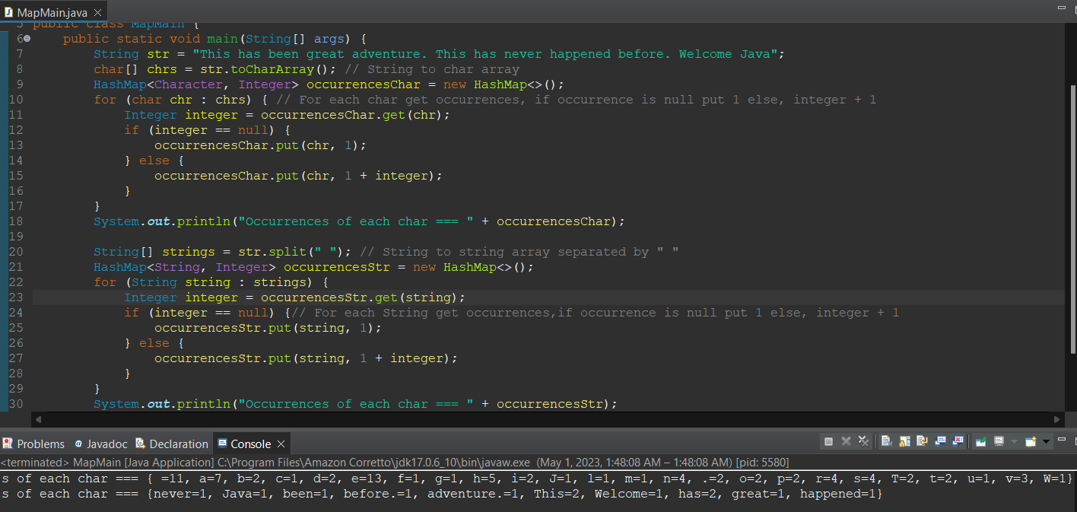

* ***TreeMap operations:*** 
  + *map.higherKey(“K”) 🡪 Returns value next higher key to key in a map.*
  + *map.ceilingKey(“K”) 🡪 Returns value equal/next higher key to key in a map.*
  + *map.floorKey(“K”) 🡪 Returns value next lower key to key in a map.*
  + *map.lowerKey(“K”) 🡪 Returns value equal/next higher key to key in a map.*
  + *map.lastEntry() 🡪 Returns last key:value in a map.*
  + *map.firstEntry() 🡪 Returns last key:value in a map.*
  + *map.subMap(“K1”,true,”K2”,true) 🡪 Returns keys between including equal to k1 and k2 in a map.*
  + *map.subMap(“K1”,”K2”) 🡪 Returns keys between k1 and k2 in a map.*

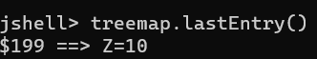

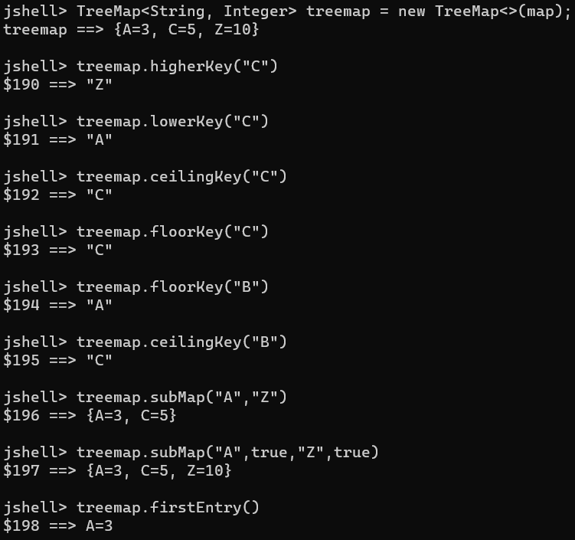

* ***Generics:*** In a list we need to define a specific data type for it to work. *Generics solves this problem, where we make our class generics and define <T>, which generalizes for every data type. When we add extends in a generic, we can restrict type (<T extends Number>), as well as we get a benefit of using (Number) class methods.*

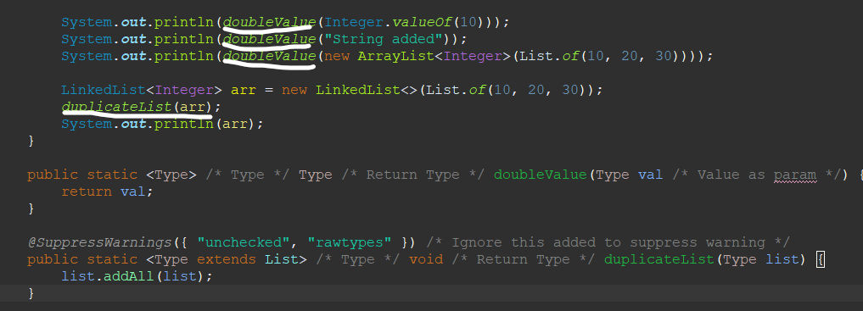

* ***Upper Bound Wildcard/Lower Bound Wildcard:*** *The Upper Bounded Wildcards shows that an upper bounded wildcard restricts the unknown type to be a specific type or a subtype of that type and is represented using extends keyword. In a similar way, a lower bounded wildcard restricts the unknown type to be a specific type or a super type of that type.* 
  + *A lower bounded wildcard is expressed using the wildcard character ('?'), following by the super keyword, followed by its lower bound: <? super A>.*
  + *A higher bounded wildcard is expressed using the wildcard character ('?'), following by the extend keyword, followed by its higher bound: <? extends A>.*

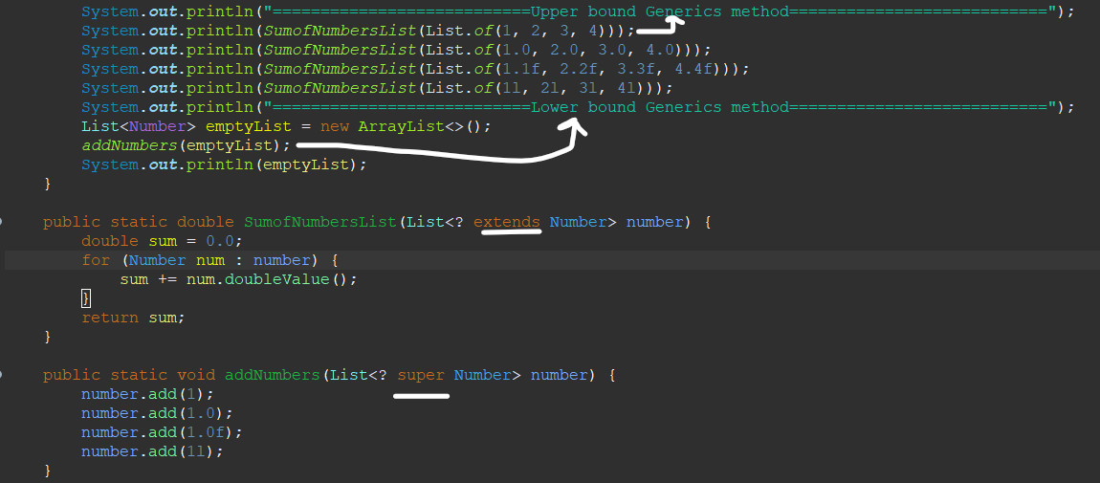

* ***Functional Programming:*** *In functional programming we pass function as parameter, function can be assigned to a variable etc.* Ex: Use of lambda expression.

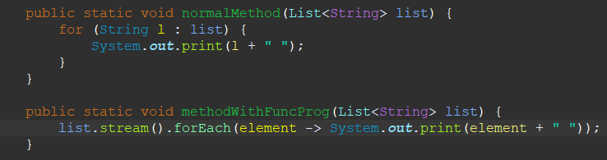

* *Benefits of Functional Programming:* 
  + *It reduces mutation of variables as we do in normal method. For ex: if we are doing sum, first we initialize sum to 0 then it’s value changes again and again.*
  + *We need not to define line by line on what to do with each statement. For ex: writing for loop, in functional programming we simply get values from a .foreach().*
* ***Basic stream terms and operations:***
  + ***Intermediate operation****: Operations/actions performed on a stream.*
  + ***Terminal operations****: Operations/actions performed on a stream inside element.*
  + ***Lambda Expression****: It is a short block of code which takes in parameters and returns a value.*
  + ***Optional****: The result of compare might be null or it will be result, in that case optional comes. To remove this you can do .get() or .orElse(0)*
  + ***.stream()*** *🡪 Output of one stream is always another stream. Stream is object of any type. It is a byte stream.*
  + ***.filter(element -> <action>)*** *🡪 Filters elements based on action otherwise will not execute next line.*
  + ***.foreach(element -> <action>)*** *🡪 Loops through each elements based on action.*
  + ***.reduce(<StartNum or 0>, (num1, num2) -> <action>)*** *🡪 Reduces elements one by one to a single value based on action.*
  + ***.distinct()*** *🡪 Extracts distinct elements from a stream.*
  + ***.sorted()*** *🡪 Gives the stream result in sorted form of ascending order.*
  + ***.map(element -> <action>)*** *🡪 Maps the stream in the form of the action defined.*
  + ***IntStream.range(<start>,<end>)*** *🡪 Stream of numbers b/w <start> and <end>(<end> value not included). Ex: IntStream.range(0, 10) 🡪 0 to 9.*
  + ***.boxed()*** *🡪 It puts each value in the stream in its corresponding wrapper class.*
  + ***.collect(Collectors.toList())*** *🡪 It returns a Collector Interface that gathers the input data onto a new list.*
  + ***.get()*** *🡪 It returns the result of lambda expression into a int.*
  + ***.orElse(<action>) 🡪*** *Assigns an value or performs action at the end of stream.*
  + ***.isEmpty() 🡪*** *Works with optional var only. Checks if the result came in optional is present in stream or not. True/False.*
  + ***.isPresent() 🡪*** *Works with optional var only. Checks if the result came in optional is present in stream or not. True/False.*

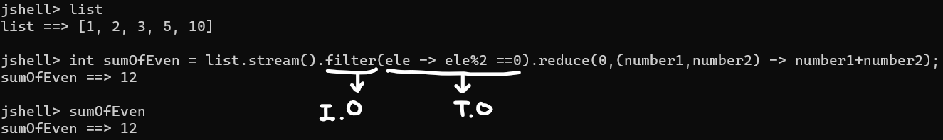

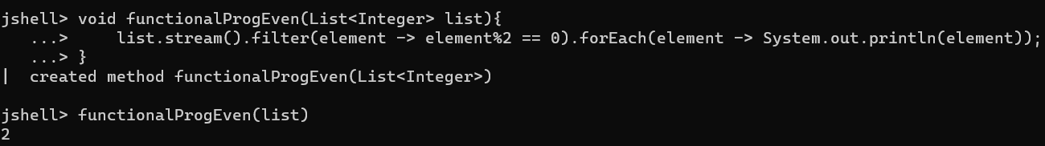 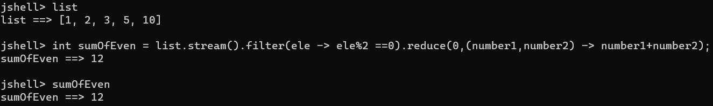

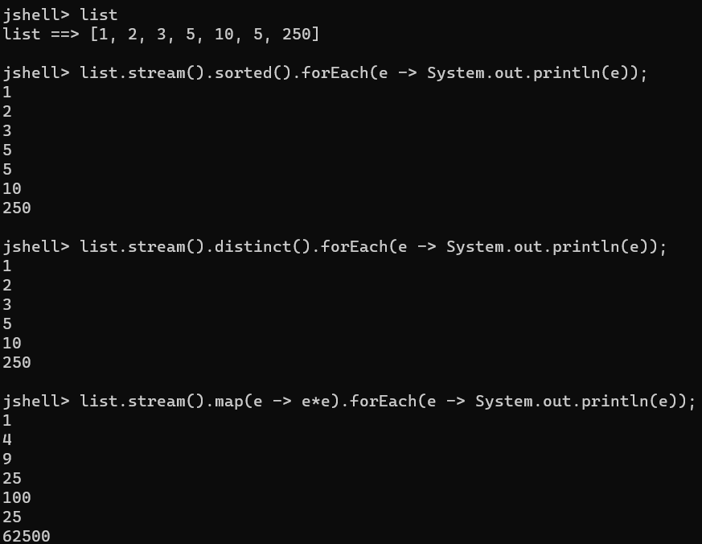

**

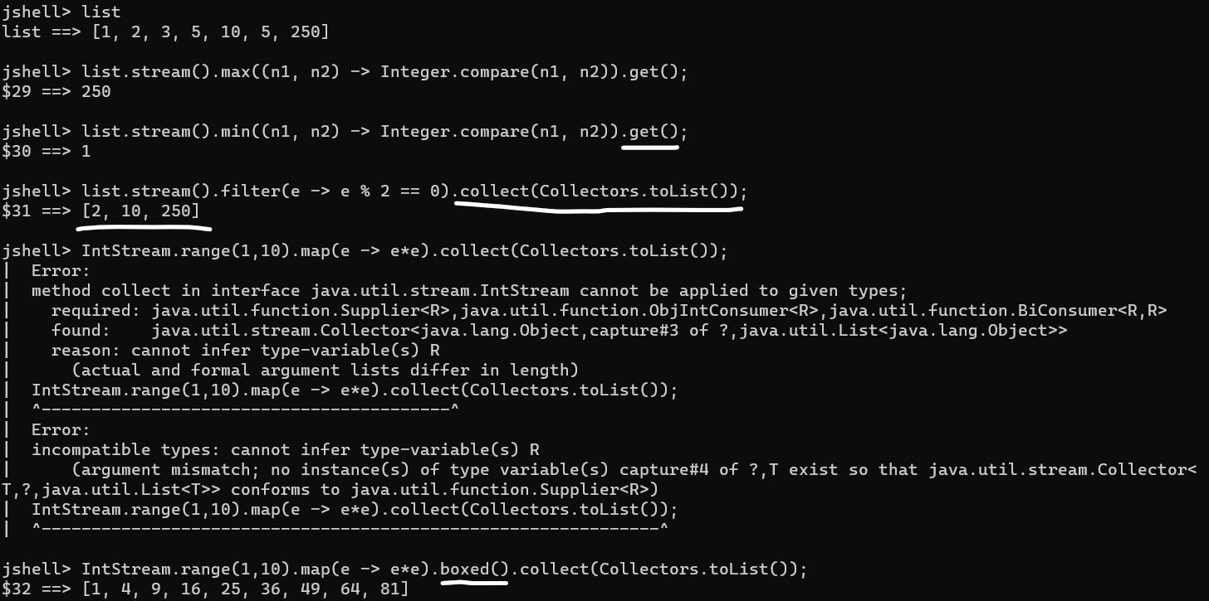

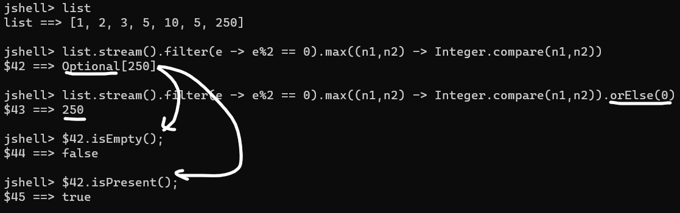

* ***Behind the scenes of Lambda Expression:*** 
  + ***Predicate:*** *For example .filter uses an interface Predicate which has an unimplemented method "boolean test(T t);" so when we pass some action in*

*".filter(n -> n % 2 == 0)" basically we're implementing the body of*

*"boolean test(T t);" which returns result as true or false or we're doing*

*method overriding.*

* + ***Consumer:*** *For example .forEach uses an interface Consumer which has an unimplemented method "void accept(T t);" so when we pass some action in*

*".forEach(e -> System.out.println(e))" basically we're implementing the body*

*of "void accept(T t);" which accept result and doesn’t return any result.*

* + ***Function:*** *For example .map uses a interface Function which has an unimplemented method "R apply(T t);" so when we pass some action in*

*"..map(e -> e * e)" basically we're implementing the body of ".map(e -> e * e)" which accept result and returns result in same object .*

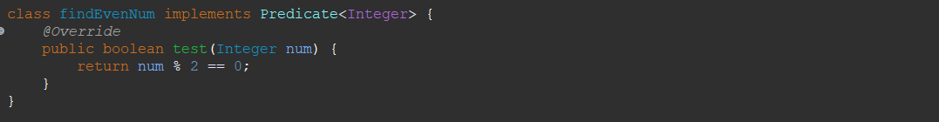

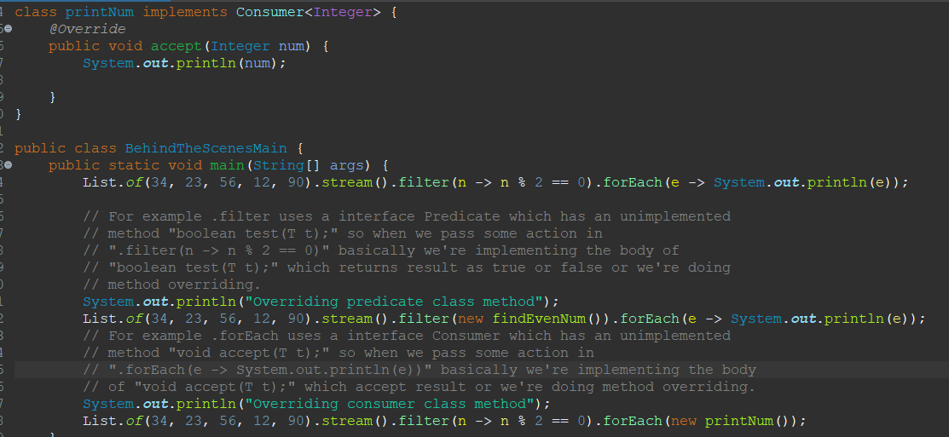

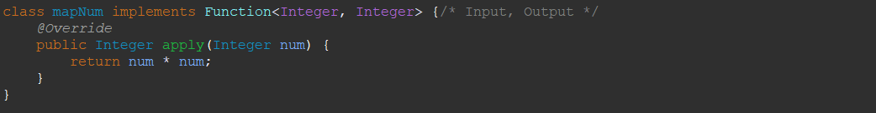

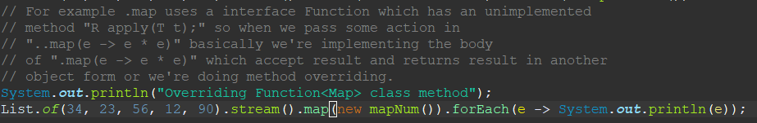

* ***Method References:*** *Method references makes our code more readable format. <ClassName::MethodName>.*

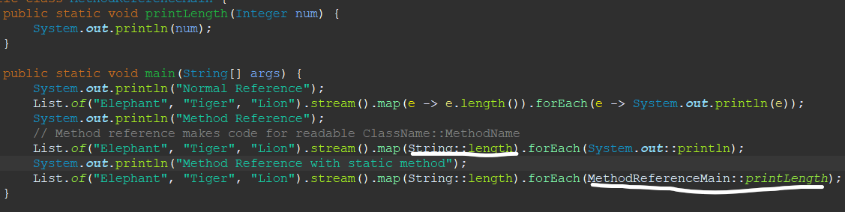

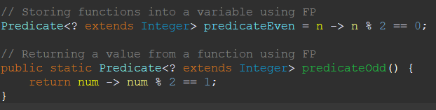

* ***Threads and Multi-Threading:*** *Threading is use to increase the CPU utilization since if a there are 3 tasks running, generally then task1 completes then task2 runs and then task3, during the time we can use threads to improve CPU utilization for parallel processing. It can be done using 2 ways:* 
  + *By extending Thread class.*

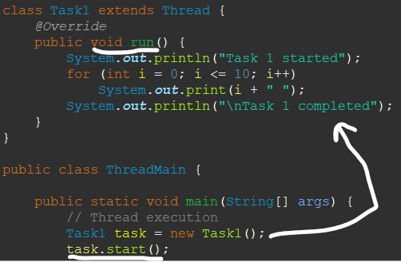

***Note:*** *If we call task.run() 🡪 Normal execution, task.start() 🡪 Parallel processing*

* + *By implementing Runnable interface.*

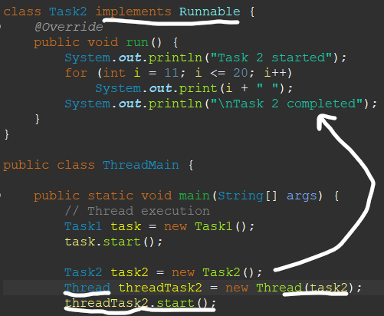

* ***States of Thread:***
  + ***NEW****: When task thread is created but not yet started (objname.start() not called).*
  + ***RUNNABLE***: *When one thread is running while the other thread is in wait state.*
  + ***RUNNING***: *When thread is* *running or executing.*
  + ***BLOCKED/WAITING:*** *When thread is waiting for an external process to complete and provide the data. Ex: In a thread a DB call happened, thread will be blocked/waiting till it receives the data.*
  + ***TERMINATED/DEAD****: When thread has completed it’s execution.*
* ***Priority:*** *Priority = 1 (MIN), Priority = 5 (NORMAL), Priority = 10 (MAX). MAX priority thread will be executed first compared to NORMAL and MIN priority. Default is NORMAL. But it’s just a request it may prioritize or may not.*
  + *Set priority by <thread_Name>.setPriority(<Level>) before <thread_Name>.start()*
* ***Join:*** *When we want one thread to END and then execute next steps.*
  + *<thread_Name>.join*
* ***Sleep:*** *When we want to thread to wait.* 
  + *<thread_Name>.sleep(<time_in_ms>)*
* ***Yield:*** *A yield() method is a static method of Thread class and it can stop the currently executing thread and will give a chance to other waiting threads of the same priority.*
  + *<thread_name>.yield()*
* ***Synchronize:*** *All synchronized blocks synchronize on the same object can only have one thread executing inside them at a time. All other threads attempting to enter the synchronized block are blocked until the thread inside the synchronized block exits the block. Synchronized keyword is used in method.*
* ***Executor Service:*** *It helps to kick off multiple threads, monitor threads and it helps in writing logic if anyone thread is completed then provide execution result or wait for all threads execution to get completed.*
  + *Task1 is thread so we only passed object in it.*
  + *Task2 is runnable interface, so we needed to keep it in Thread() object first.*
  + *.submit() for callable and for thread .execute().*

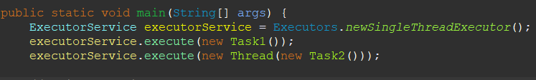

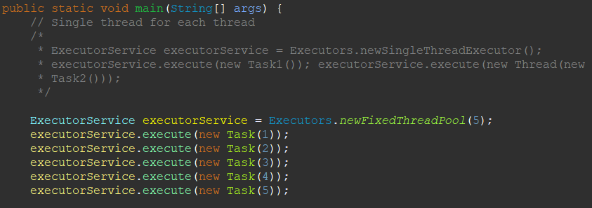

* ***Callable:*** *Callable is used when we want to return output from a task. Future in here to get result from callable or is a promise and to get the output from that we use .get() once task completes then only next execution will happen.*

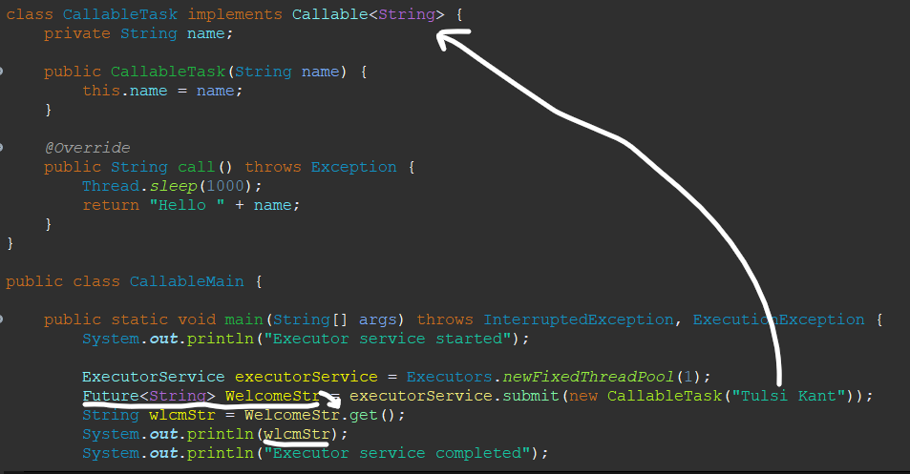

* ***Multiple Callable:*** *Multiple callable uses invokeAll() with ExecutorService object. It will return a list of Future promises and we can get that in a for loop by using .get().*

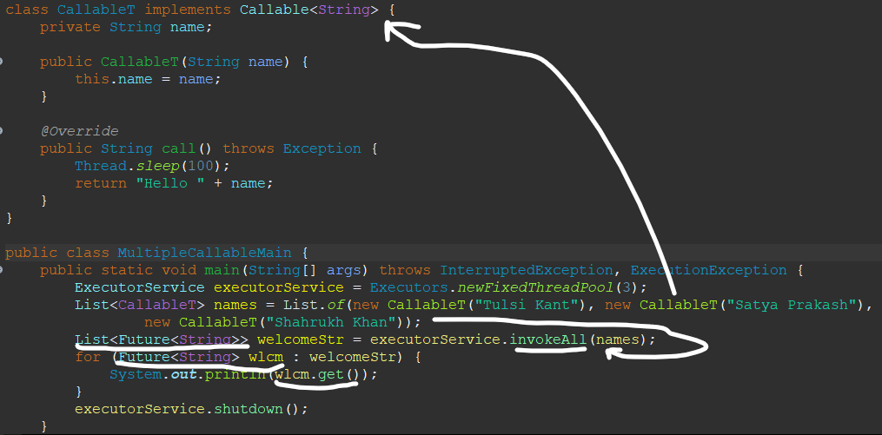

* ***invokeAny() and invokeAll():*** *invokeAny() will return a single result of whichever task is completed, whereas invokeAll() will return a single result of every task once completed.*

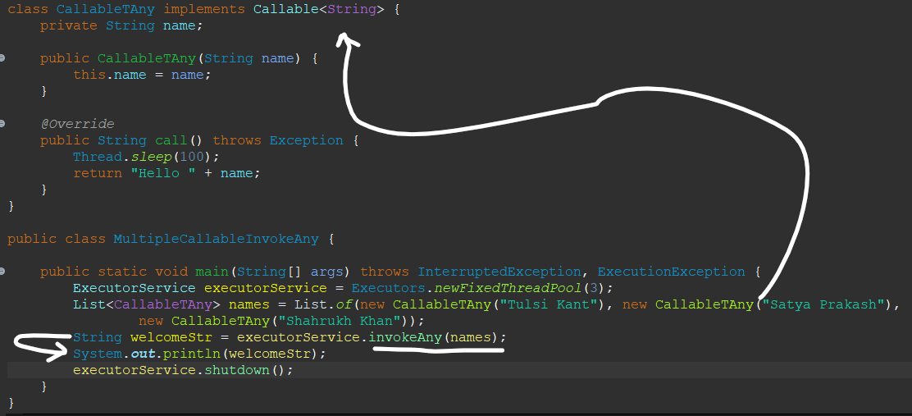

* ***Exceptions:*** *Once a Code of line causes exception, the next line won’t be executed unless exception handling is done. Once exception is handled, the method calling exception causing method will be executed, w/o any interruption.*
  + ***Exception*** *is a class in Java and all other exceptions are subclass (NullPointerException, ArithmeticException etc extends Exception)*
  + *If there are multiple catch blocks then only specific exception block is executed otherwise general exception will be executed.*
  + *If multiple exceptions are there then first exception will be executed only, other exception won’t be executed.*
  + *Try block can have either catch or finally as a must. But it can’t be just try block.*

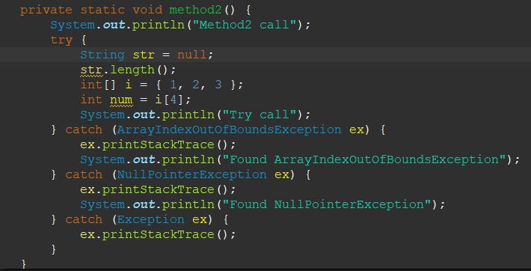

* ***Finally:*** *Even if exception is there or not, return is there, finally block will be executed anyway. Only time finally won’t be executed if the code inside finally block throws exception itself or JVM crashes (System.exit(1)).*
* ***Errors vs Exception:*** Errors are which can’t be handled unlike exception. You can prevent them but not handle them.
* ***Checked Exception vs Unchecked Exception:*** *Exceptions which directly are subclasses of Exception class are checked exceptions. Checked exceptions are mandatory to be handled. Exceptions which are subclasses of RuntimeException (which is a subclass of exception) is called Unchecked exception. Unchecked exceptions are not mandatory to be handled.*

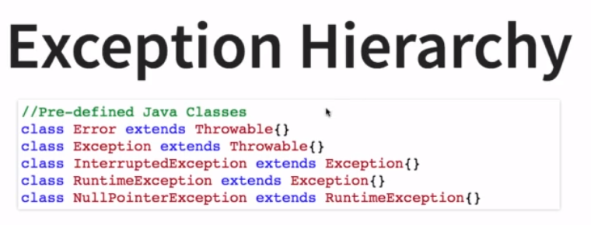

* ***Custom exception:*** 
  + *throw new RuntimeException(<Exception>) 🡪 Don’t need to specify in main class that it will throw an exception.*

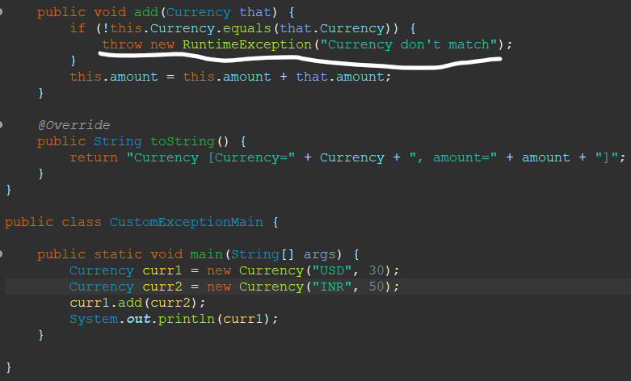

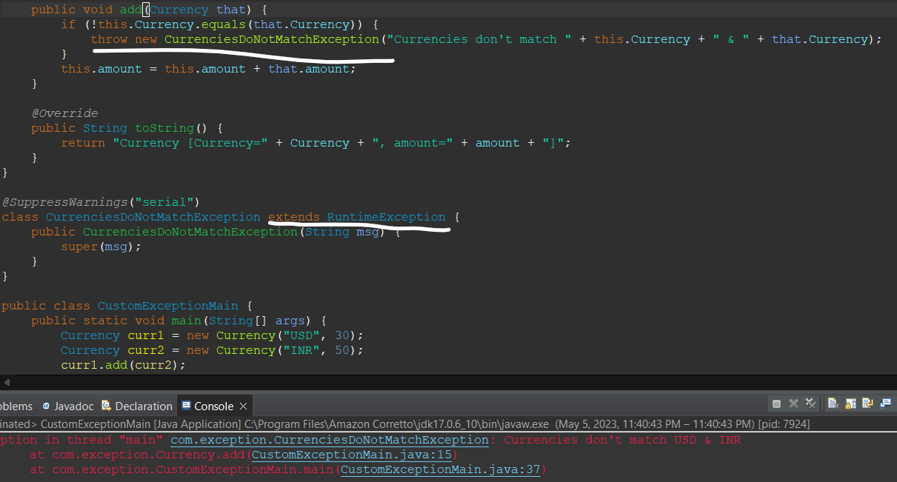

* + *throw new Exception(<Exception>)🡪 Need to add throws in main class that it will throw an exception.*

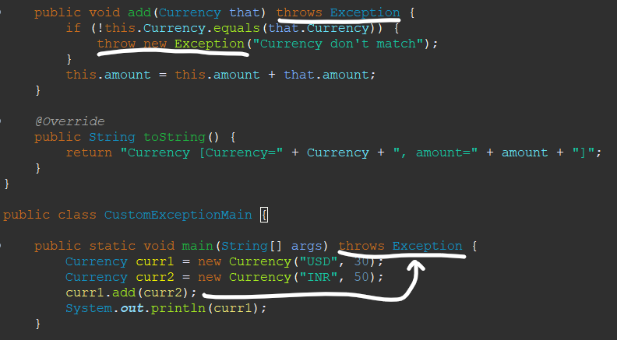

* + *throw new <CustomExceptionClass>(<CustomException>)🡪 Need to add throws in main class that it will throw an exception.*

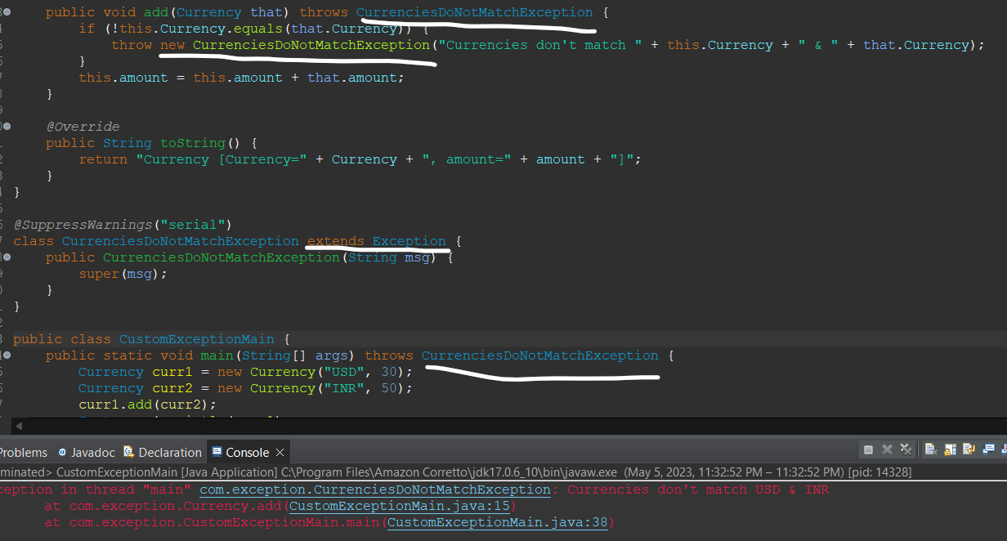

* ***try with resources:*** *try with resources is a new feature in Java 7 with the purpose of less writing code. It doesn’t require mandatory catch and finally block. Although if we want we can specify with catch and finally as well. It has auto close method, which will auto close variable in try block once exception is thrown. try(<Exception>){}*

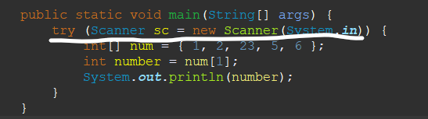

* ***In this example below exception thrown by String is NullPointerException but in catch blocks we’re handling Exception and CurrenciesDoNotMatchException only. Hence it will not be handled by either and catch block won’t be executed and the order of exceptions should be in hierarchy which is wrong in here, Subclass then Superclass, CurrenciesDoNotMatchException then RuntimeException then Exception.***

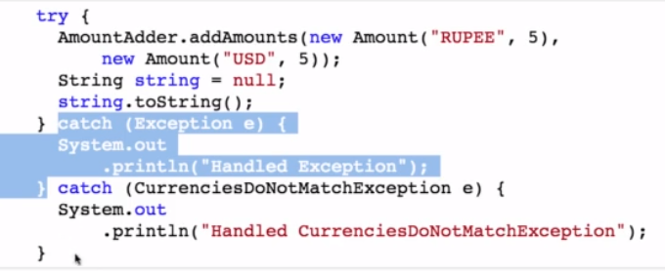

* ***Define multiple exceptions:*** *Using | character we can define multiple exceptions. From Java 7 onwards.*

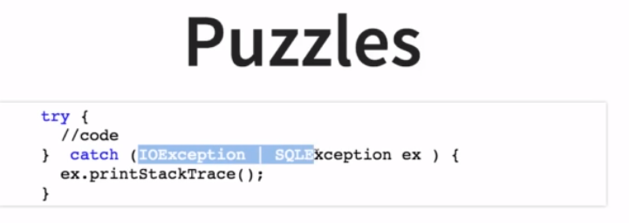

* ***Reading Files in Java:*** 
  + *Paths.get(<Path_to_file>): Gets the path to the file.*
  + *Files.readAllLines(<Path_Obj>): Reads all lines in a file in a single line.*
  + *Files.lines(<Path_Obj>): Reads each line in a file as it is.*

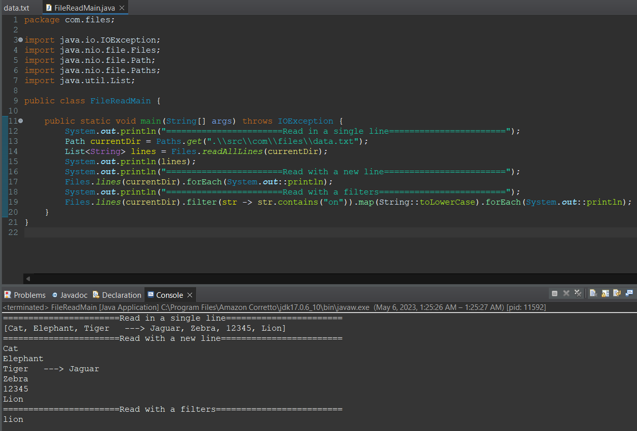

* ***Writing in a file:*** 
  + *Files.write(<path_dir>,<str>): Writes to a file.*

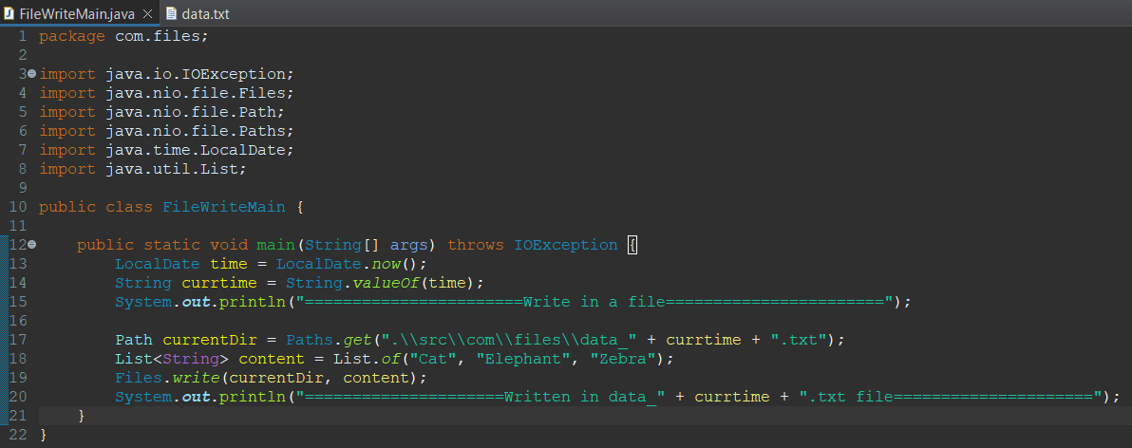

* ***Append in a file:*** 
  + *Create FileWriter object 🡪*
    - *FileWriter fw = new FileWriter(<path>,true);*

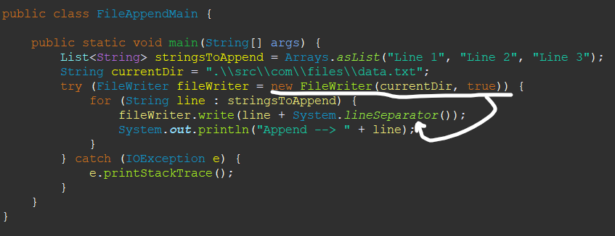

* ***Synchronized:*** *Only thread can access synchronized method, other threads will be in a wait state. But if multiple methods are defined synchronized then it will create an issue where most of the time threads will be in paused, even if the methods are not related to each other and it will impact the sole purpose of efficiency in programming.*
* ***Lock:*** *Lock comes in picture to address the issue with multiple synchronized methods. If a lock is acquired on method, the thread instead of waiting will move to next method and acquire lock. Then we don’t need to define methods as synchronized.*
  + *Create object of Lock <lock_name> = new ReentrantLock();*
  + *<lock_obj>.lock(); <lock_obj>.unlock(); 🡪 Lock and unlock locks.*
  + *<lock_obj>.tryLock() 🡪 Try to acquire lock.*

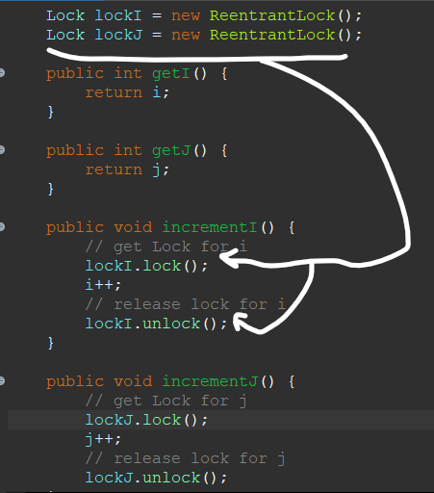

* ***Atomic Classes:*** *Atomic classes provides thread safety and we need not to use synchronized and locks to address thread safety for simple operations like counter and provides range of operations like incrementAndGet(), get(), set().*

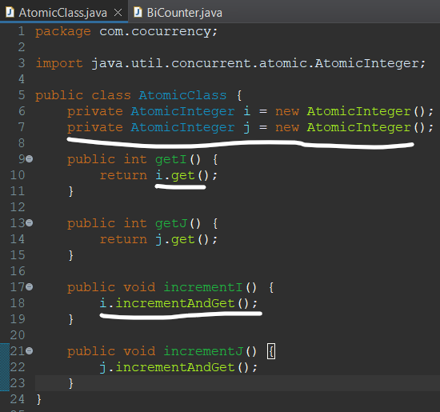

* ***Concurrent Collections:*** *It provides thread safety (two threads might try to access same function) without any significant impact. LongAdder class in Java creates a new adder with an initial sum of zero. LongAdder is a very efficient way to increment a counter from multiple threads.*

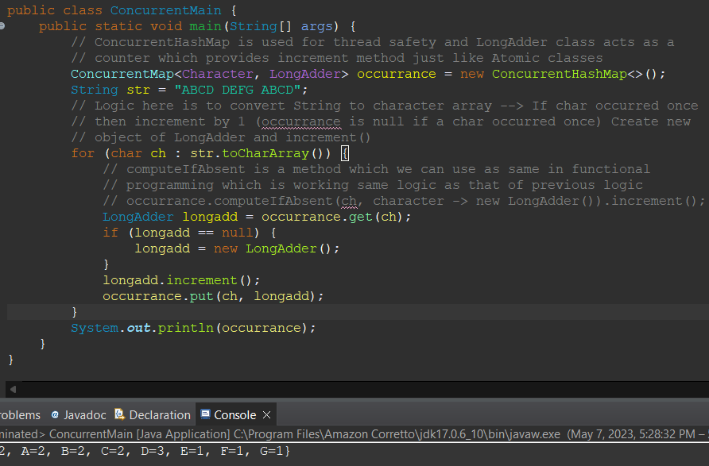

* + *Concurrent hashmap has different locks for different regions hence increasing the efficiency. For ex: If Concurrent hashmap is doing update at region 2 the method doesn’t need to wait for an update on same region, it can meanwhile perform updates for different location.*

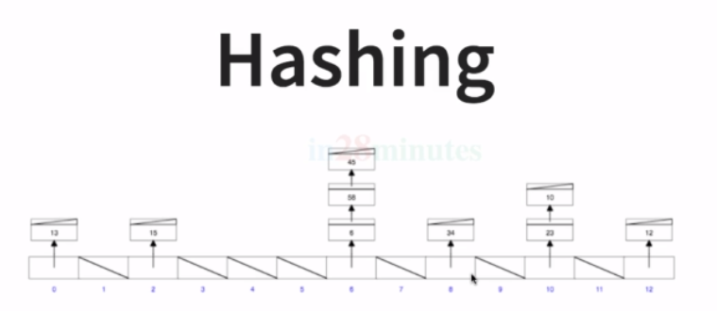

* ***CopyOnWriteArrayList/CopyOnWriteArraySet:*** *It provides same operations as that of an ArrayList. It offers more thread safety when compared to ArrayList, since during update or adding new element it creates a new copy of previous ArrayList, which makes operation efficient in terms of thread safety although it is very costly operation. Only for adding new elements it creates a new copy of ArrayList not for reading the ArrayList.*

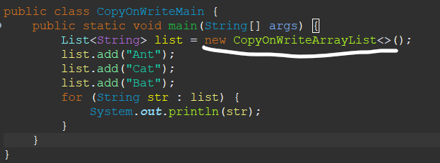

* ***Java Tips:*** 
  + ***String****: Comes in a default java.lang package String class which is by default import, so you need not to add it externally. See below no imports required.*

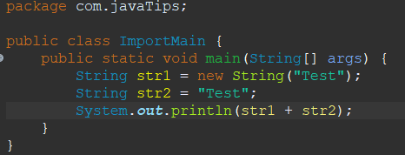

* + ***Static Imports:*** *You can static import a class function and then you can use directly by calling method name.*

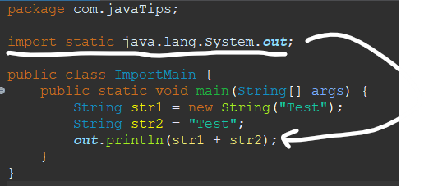

* + ***Blocks:*** *A variable declared in a block, can’t be accessed outside.*
  + ***Equals:*** *equals() by default compares object if they are referring to the same object location or not. But if we override the equals() then we can compare the values.*

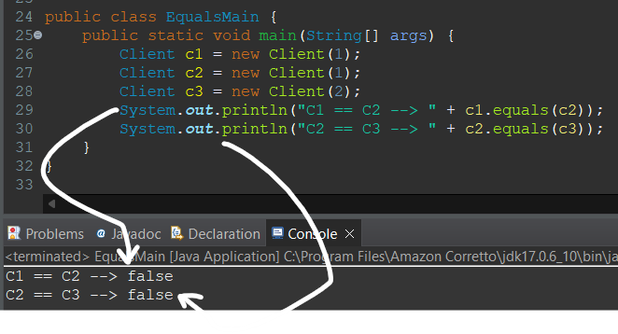

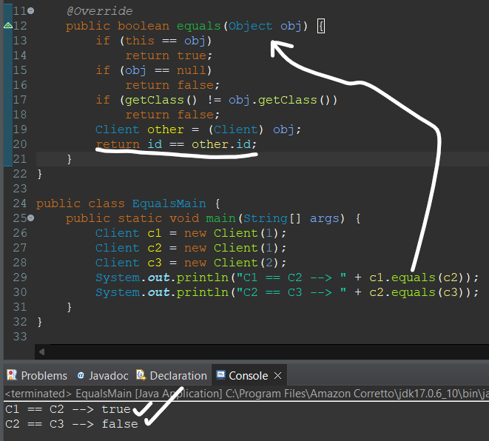

* + ***HashCode:*** *Based on hashing code, the elements are placed in buckets of a HashMap. The efficiency depends on the Hash code/function implement.* 
    - *HashCode for 2 same IDs or elements should be same.*
    - *Value of HashCode should not be different for different elements.*

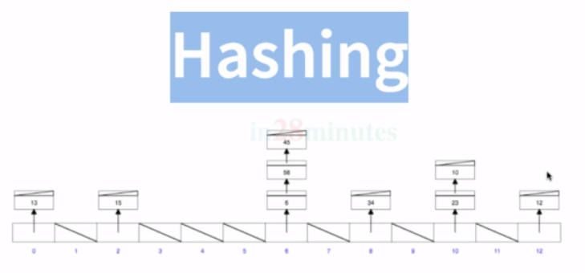

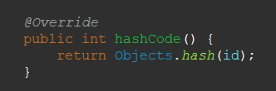

* + ***Class Level Access Modifiers:*** *Defines the level of access of a class inside or outside package.*
    - ***Public:*** *Can be accessed anywhere inside class, outside different packages.*
    - ***Default:*** *Can be accessed within class or same package.*
    - ***Protected/Private:*** *Can’t be used on classes.*
  + ***Method/Variables Level Access Modifier:*** *Defines the level of access of each method in a class.*
    - ***Public:*** *It can be accessed anywhere (wherever you can access class).*
    - ***Default:*** *It cannot be accessed in different package, but it can in same package or in same class.*
    - ***Protected:*** *It cannot be accessed in different package, but it can in same package or if it’s subclasses.*
    - ***Private:*** *It cannot be accessed outside the class and is only specific to the class.*
  + ***Non-Access Modifiers:*** *It can be used on class, method and variables.*
    - ***Final:*** *It cannot be modified by subclasses extending final class and method overriding Final methods. Once a Final variable is assigned a value, it cannot be changed.*

*Ex: String, Integer.*

*final int i; final int i = 7;*

***i = 5; //Value initialized so it’s correct i=8//Value is being modified so not correct;***

* + - *In case of Final arguments it can’t be modified, overridden or even initialized.*

*Ex: public doSome(final int i){i=6;} (Wrong)*

* + - ***Static:*** *When we don’t want a variable to create separate instances, instead use a common instance to update values. We want multiple objects to use a common variable, we use static variables.*
    - *Static methods cannot have any non-static variables i.e., static method should have static variables only, but a non-static method can have static variables.*

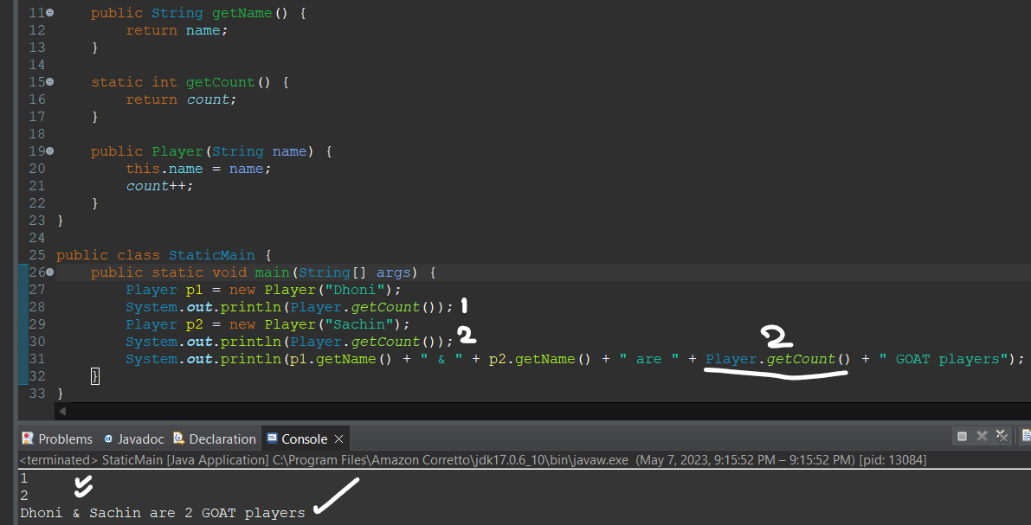

* + - ***public static final:*** *We declare a variable as public static final, so it’s value is fixed and can be accessed anywhere (ClassName.VarName). Ex: Integer.****MIN_VALUE****, Integer.****MAX_VALUE****.*

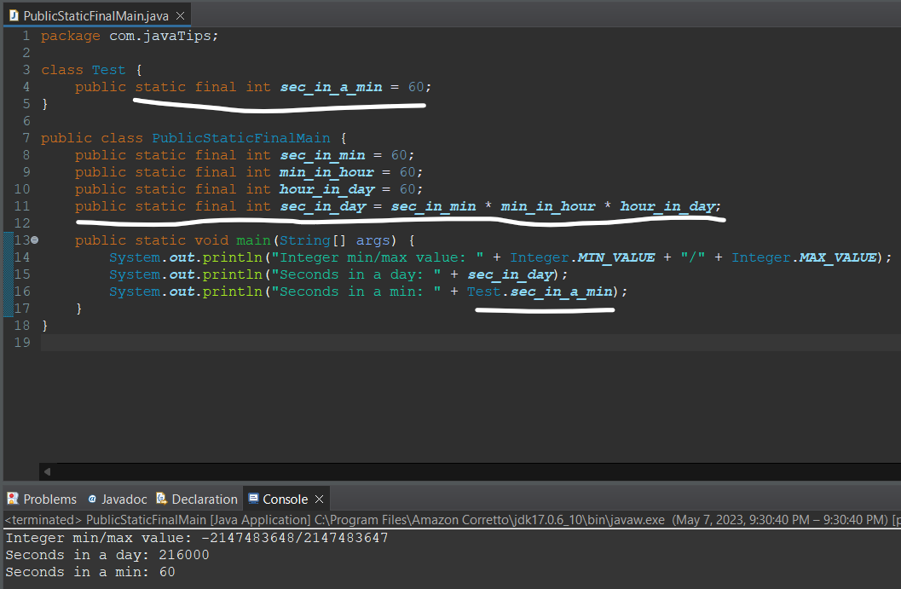

* ***NestedClass and StaticNestedClass:*** *A class can have another class, default and static class.*
  + ***Default:*** *You can’t create an object of nested class enclosed in class without object of enclosing class. You can use enclosing class variables inside static class.*
  + ***Static:*** *You can create an object of static class without having to create object of enclosing class. You can’t use enclosing class variables inside static class.*

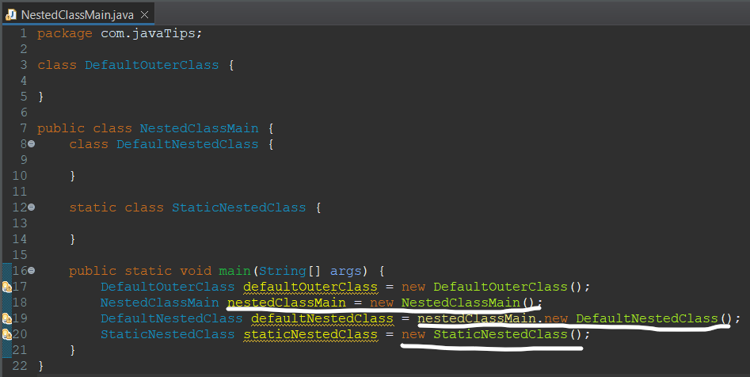

* ***Anonymous class:*** *Any class that doesn’t have a name is called Anonymous class. Ex: Comparator class is an interface in Collections, but here we didn’t created any class instead, using object we overridden the compare method. In case we don’t need to create or use comparator somewhere else, instead of creating a class we can create anonymous class in that case.*

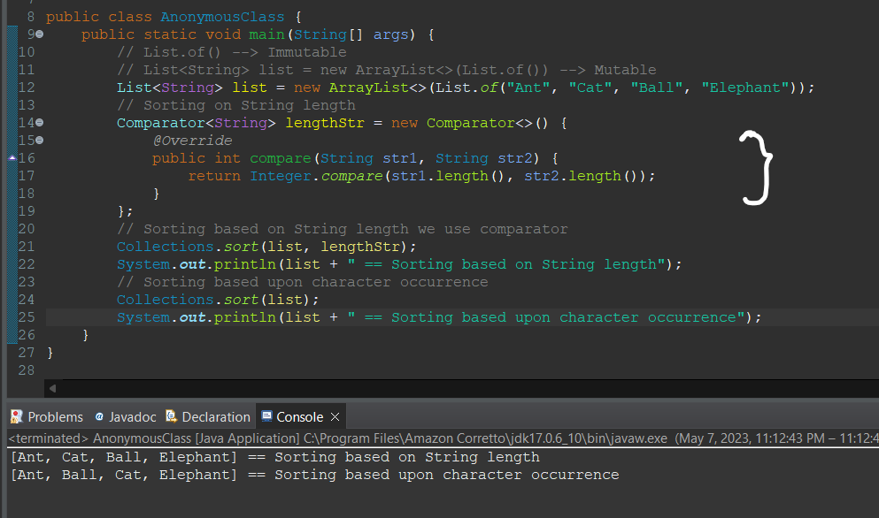

* ***Enum (Enumeration):*** *Enum allows you to restrict the values it contains.*

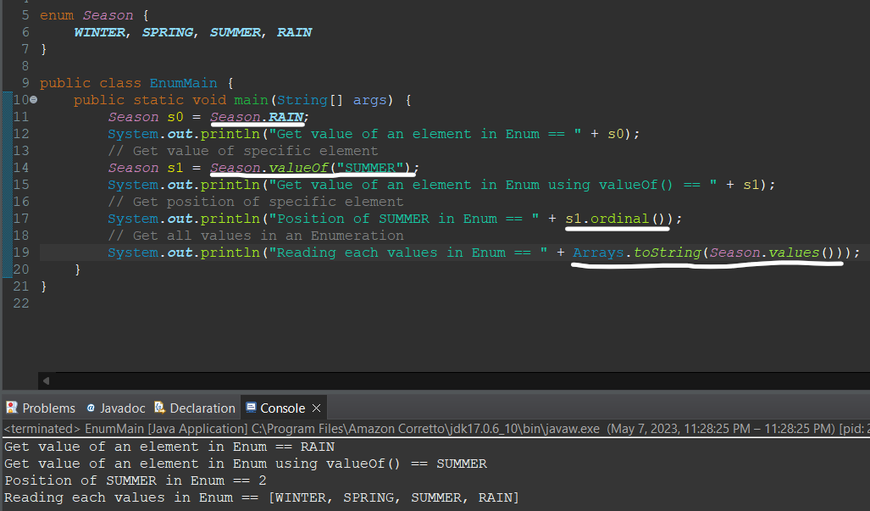

* ***Assigning values in an Enum:*** *Once value assigned to elements in enum, it will not change irrespective of position. Making enum public and even if stored in other packages, it can be accessed. Java provides some basic enum like* ***DayOfWeek()*** *and* ***MonthOfYear()****.*

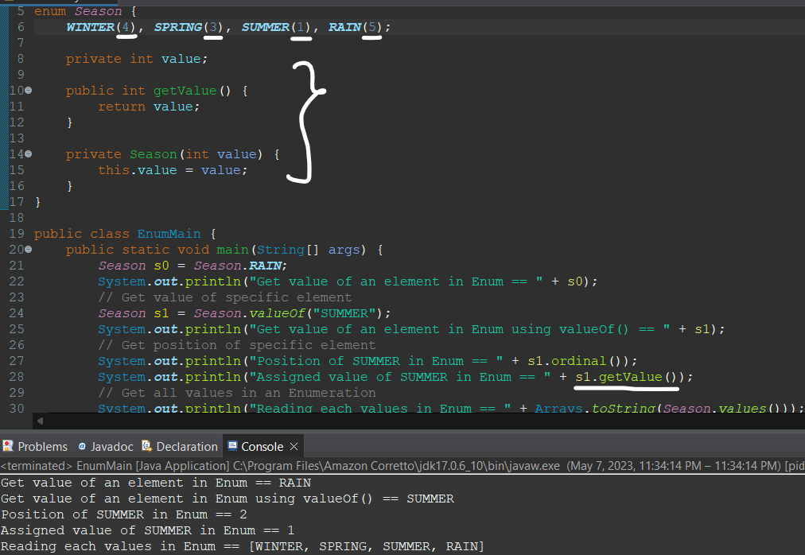

* ***Java New Features (Java 10 to 16):*** *Oracle support LTS version as they support for longer period. Java 8 SE introduced Functional Programming, lambda function etc.*

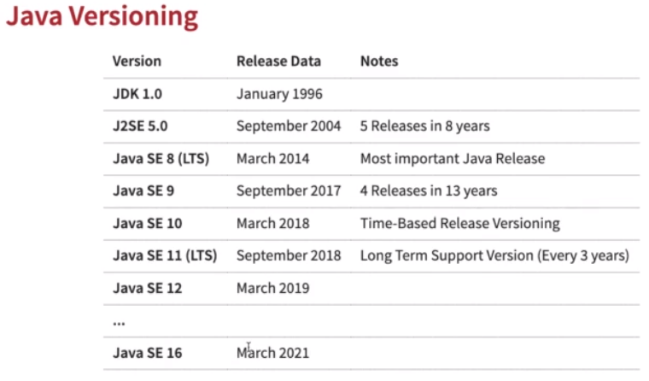

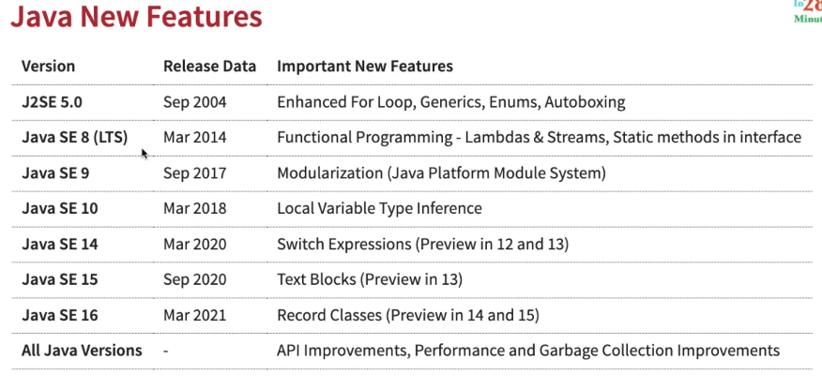

* ***Modularization:*** *Assume we create class, where there is class SortingAlgorithm and BubbleSortUtil implementing sort algorithm, but when we share mainSortingAlgo code some can directly implement BubbleSortUtil and start using sort method in that and we only want SortingAlgorithm to be used. This is not well encapsulated. Modularization provides better control over packages. When creating a package you can add Module.info in your code.*
  + *To be able to leverage strong encapsulation.*
  + *For establishing well-defined interfaces for modules communication.*
  + *For defining explicit dependencies.*

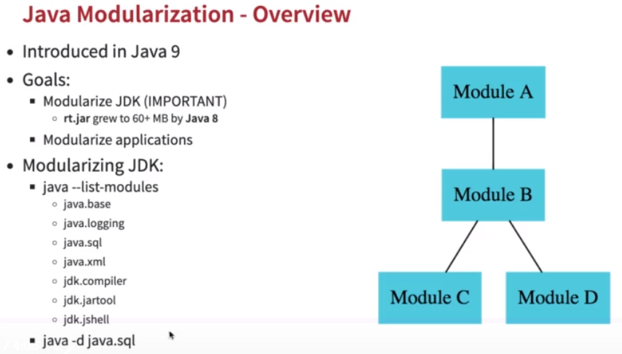

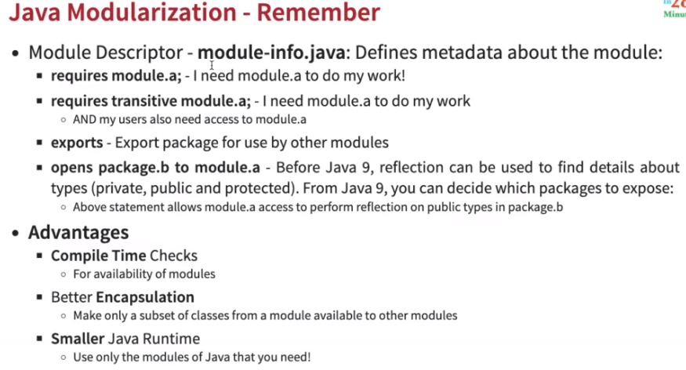

*We can control which modules are needed to be exported only.*

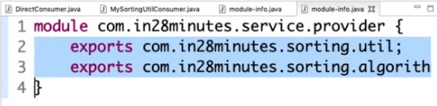

*We can check what modules the code requires.*

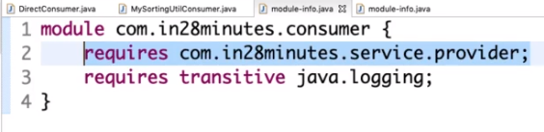

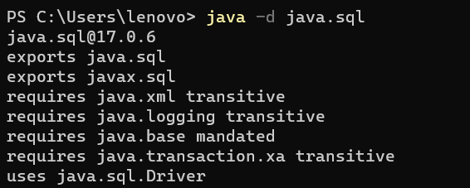

* ***Adding logger to a class :*** 
  + *private static Logger logger = Logger.getLogger(<Class>.getName());*
  + *logger.info(<String>)*
* ***Java APIs***
  + ***List/Set/Map.copyOf()*** *🡪 It creates an immutable List and sends immutable list to next control flow.*

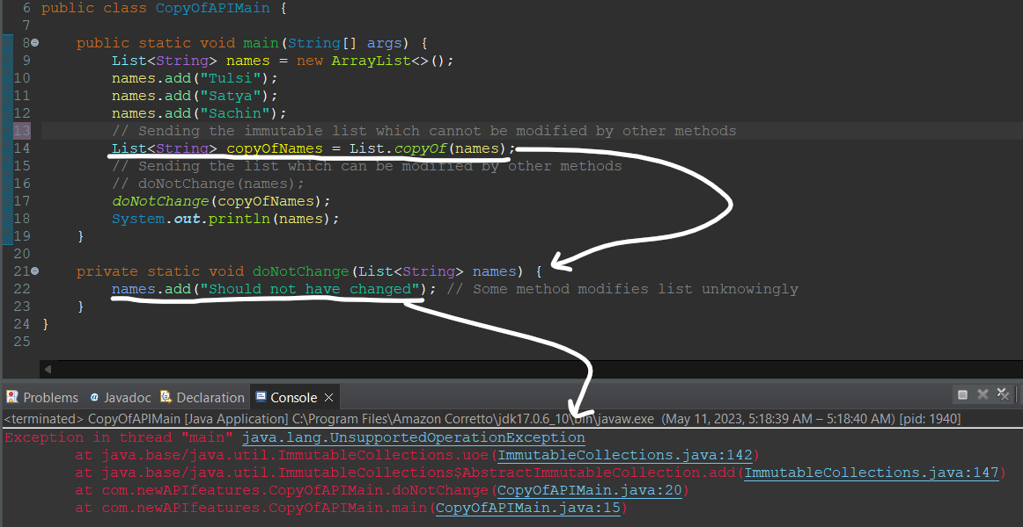

* + ***Files.readString()/Files.writeString():*** *Read/Writes into files.*

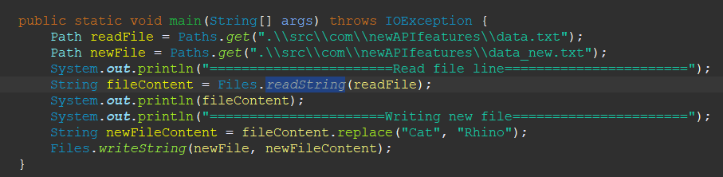

* + ***Predicate:*** *This would test a value or an object with a condition and returns a boolean value. Introduced in Java 11.*
    - ***Predicate<Type> <name> = <expression>****🡪* Predicate syntax.
    - ***<Predicate>.negate()****🡪*Opposite result of predicate.
    - ***Predicate.not(<method>)****🡪* Opposite result of predicate in case of functions.

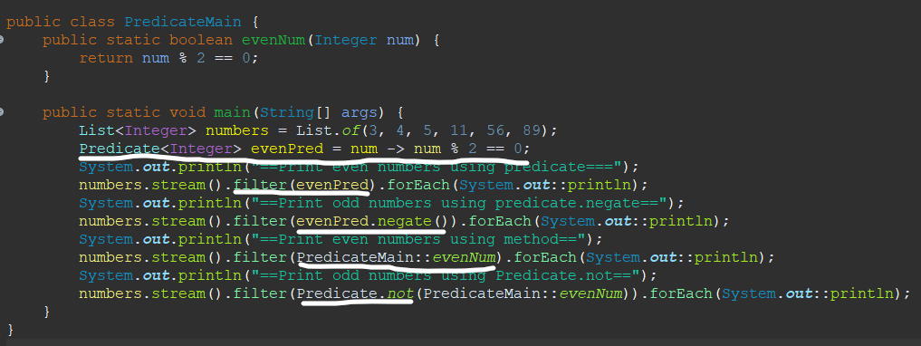

* + ***String APIs:*** 
    - ***<String>.isBlank()*** *🡪 Checks if String has non-white space. Returns Boolean.*
    - ***<String>.strip()*** *🡪 Removes white spaces from left/right sides in string.*
    - ***<String>.stripLeading()*** *🡪 Removes white spaces from left side in string.*
    - ***<String>.stripTrailing()*** *🡪 Removes white spaces from right side in string.*
    - ***<String>.lines()*** *🡪 Splits string into multiple lines separated by terminators(\n) and return a stream.*
    - ***<String>.transform(<expression>)****🡪 Using expression transforms a string.*
    - ***<String>.formatted(<value>)*** *🡪 String formatter (%d 🡪 replaces with int).*

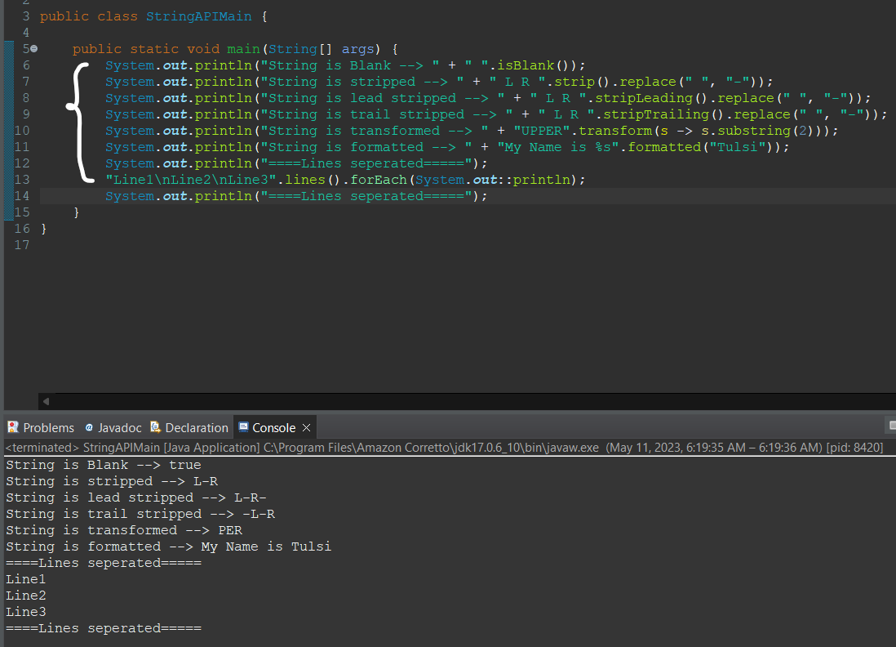

* ***Local Variable Type References: var*** *keyword was introduced. var keyword is never null, can be declared final, makes easy writing and type of var is decided at compile time.*

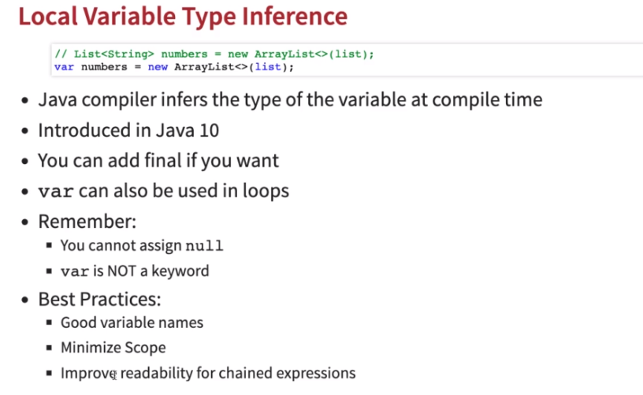

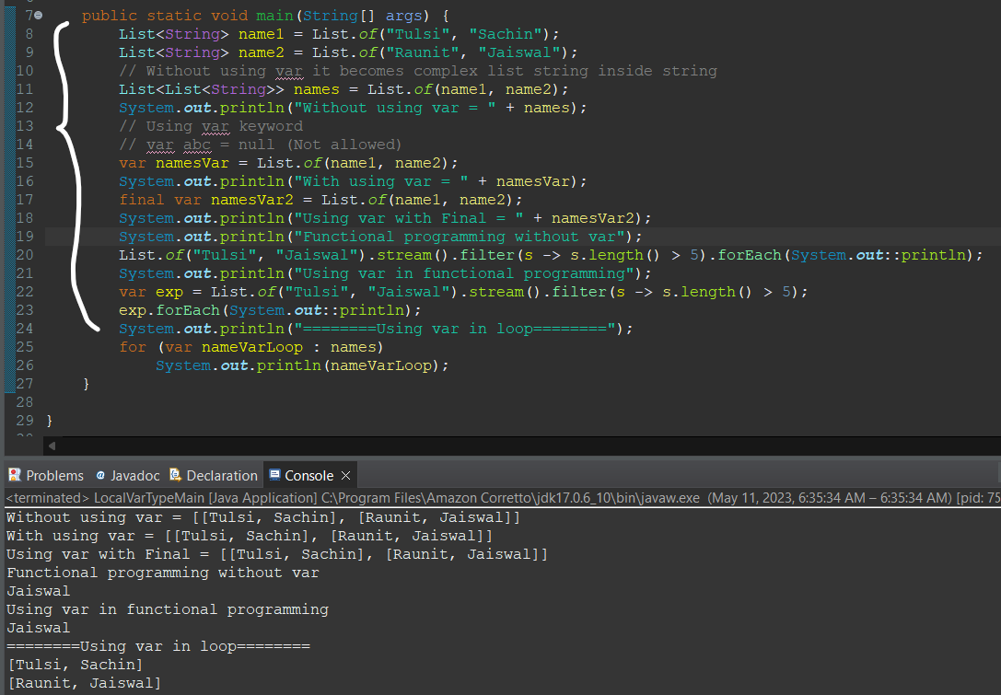

* ***Switch Expression:*** *New Switch expression doesn’t breaks to be defined, yield can be used to return specific value. New Switch expression directly returns values instead of going through fallthrough or next lines.*

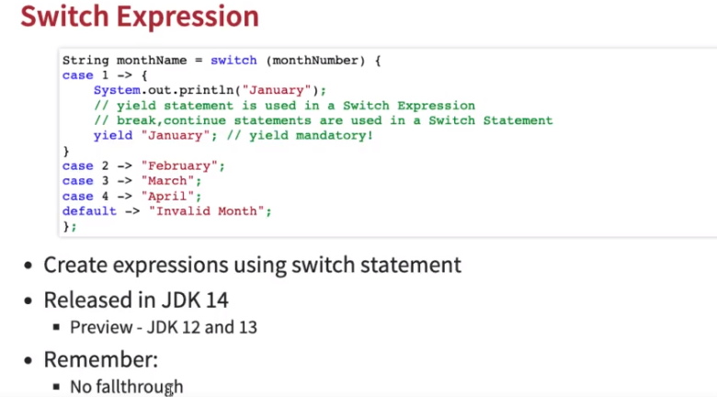

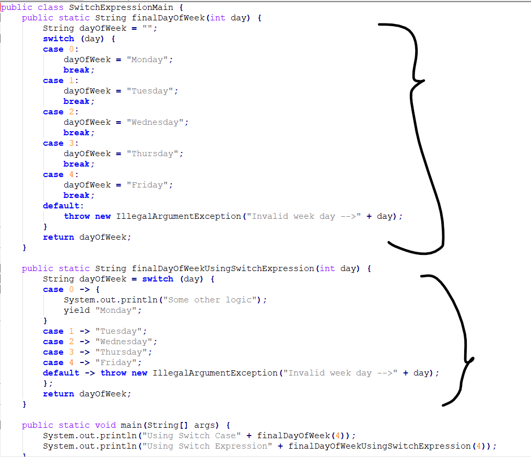

* ***Text Blocks:*** *Starts with* ***“””*** *and ends with* ***“””****. It keeps the format as it is for the string in the text block and can be used as string.*

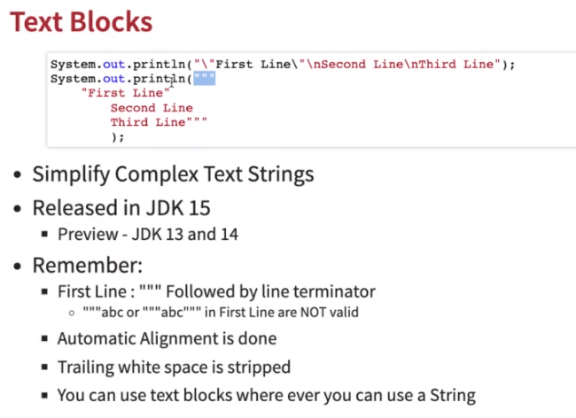 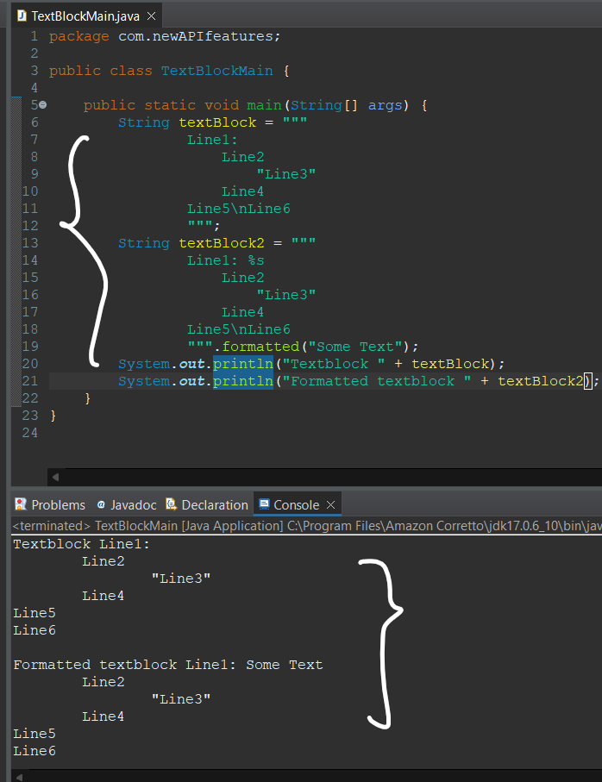

* ***Records:*** *Records are easiest way to create Java bean classes.*

